

Opioid Use/Misuse
Community Needs Assessment 2023

Humboldt County, Nevada
November 9, 2023

Acknowledgments

The Humboldt County Commission acknowledges and appreciates the expertise and commitment of the members of the Humboldt County Opioid Task Force and thanks them for their work on behalf of Humboldt County, and a special thank you to Pauline Salla, Director of Juvenile Services, for leading the Task Force.
The Humboldt County Opioid Task Force would like to thank the many community members who participated in the assessment process, including organizers, panelists, and participants at the Humboldt County Opioid Summit.
Additionally, the Task Force would like to thank the Nevada Association of Counties (NACO) Public Health Coordinator, the State of Nevada Department of Health and Human Services Director’s Office & Office of Analytics, and the Rural Region Behavioral Health Coordinator for their support in completing the assessment.
Finally, Mercer Consulting provided guidance and technical assistance throughout the assessment and prioritization process and detailed guidance on implementing the identified community priorities. Thank you to the Mercer team.

Opioid Litigation Needs Assessment Committee Members

Honorable Michael R. Montero Commissioner Jesse Hill
Robyn Dunckhorst, HGH CEO Chief Mike Rangel, WPD
Captain Jeremy Peters, HCSO Sgt. John Dunckhorst, NDI, NSP
Pauline Salla, Director HCJS Jeanette Montero, HCSD Social Worker
Brooke Esquibel, FCC Coordinator Sgt. Zach Peterson, Adult P & P
Eric Silva, SSR Mining Val Teichert, Family Support Center
Fergus Laughridge, Fort McDermitt Health Director Denni Bird, HCHS
Gina Rackley, Humboldt County Comptroller

Table of Contents
Acknowledgments 2
Executive Summary 5
Section 1: Background and Community Profile 7
1.1 Background 7
1.2 Community Overview 8
1.3 Humboldt County Population Health Profile 11
Section 2: Methodology 13
2.1 Humboldt County Opioid Needs Task Force 13
2.2 Qualitative Data Collection/Community-Based Participatory Research 13
2.3 Quantitative Data Collection 15
Section 3: Quantitative Data: Opioid Use Prevalence, Impact, and Risk Factors 16
3.1 Substance Related Dependence 16
3.2 Substance Related Poisoning 19
3.3 Substance Related Overdose Deaths 20
3.4 ODMAP Data for Humboldt County 22
3.5 Opioid Prescribing 25
3.6 Opioid Use and Adult Drug Court Utilization 27
3.7 Opioid Statistics from the Tri-County Drug Enforcement Team (Tri-DENT) 29
3.8 Humboldt County Detention Center Substance Use Data 29
3.9 Parental Substance Use 30
3.10 Adult Risk Factor Prevalence 34
3.11 Youth Risk Factor Prevalence 35
Section 4: Community Opioid Needs Survey and Summit – Community-Based Participatory Research 38
4.1 Community Survey 38
4.2 Community-Based Participatory Research Summary of Recommendations 44
Section 5: Community Assets and Challenges 46
5.1 Prevention and Harm Reduction 46
5.2 Community Treatment Capacity 47
5.3 Agency-Submitted Summaries 48
5.4 Additional Assets and Community Resources 51
Section 6: Priorities and Recommendations 52
6.1 Process and Areas of Alignment 52
6.2 Areas of Alignment 52
6.3 Humboldt County Priority Areas 53
Priority 1: Prevention, Treatment, and Recovery 53
Priority 2: Education and Awareness Campaigns 60
Priority 3: Justice Programs 61
Section 7: Humboldt County Opioid Abatement Plan 62
7.1 Opioid Settlement Considerations and Allowable Uses 63
References 64

Executive Summary

In 2021, it is estimated that more than 107,000 people died of drug overdose in the United States, marking the highest ever recorded annual number of overdose deaths in the nation.1 The country’s unprecedented overdose crisis, largely driven by opioids, has left no community untouched, including Humboldt County, Nevada. In response to the alarming rates of opioid misuse, opioid use disorder (OUD), and overdose, Nevada passed Senate Bill (SB) 390 in March 2021, establishing the Fund for a Resilient Nevada (referred to in this document as “the Fund”) within the Nevada Department of Health and
Human Services (DHHS). This measure was codified at Nevada Revised Statutes (NRS)
433.712 through 433.744.

Humboldt County signed on to the One Nevada Agreement, which enables a portion of opioid recoveries facilitated by the Attorney General’s Office to be given directly to Humboldt County specifically for the abatement of the opioid epidemic in alignment with the regulations developed pursuant to SB390.
The Humboldt County Commission created the Opioid Litigation Subcommittee compromised of representatives from stakeholders who work with the opioid epidemic across socioeconomic status, race, gender, culture, age, lived experience and professional disciplines. The objectives of this group focused on the completion of a comprehensive need’s assessment, developing a funding mechanism that includes best practice and collect data that will allow for data driven decision for revisions within the need assessment. The committee met monthly in person with virtual capability and followed all open meetings requirements.
The Humboldt County Opioid Task Force convened a Community Opioid Needs Assessment Summit in April of 2023. The summit was open to all members of the community and pre-registration was circulated in advance through Humboldt County websites and news outlets. The summit panels focused on bringing perspectives from the following sectors in the community: (1) Health, Wellness & EMS; (2) Individuals with Lived Experience; (3) Law Enforcement; and (4) Business & Mining. The summit also included presentations from the Drug Enforcement Administration (DEA) on the prevalence, manufacture, and trafficking of fake synthetic opioids designed to look like pharmaceuticals, as well as an update from the State of Nevada Attorney general’s office on opioid litigation funding. The summit ended with training for all participants on the administration of naloxone and fentanyl testing strips.
The task force engaged the support of the Nevada Association of Counties Public Health Coordinator to develop the assessment report, collect secondary quantitative data, and coordinate support with the State of Nevada Department of Health and Human Services Clinical Program Manager 3 and Mercer Government Human Services Consulting (Mercer), the State-contracted provider of technical assistance to counties for Opioid Needs Assessments and Plans.

Data and information were analyzed to better understand the impact of opioid misuse on community members in Humboldt County including:

• The available quantitative and qualitative data related to substance use and rates of OUD, other substance use disorders (SUDs), and co-occurring disorders

• Health equity and the identification of disparities across racial and ethnic populations, geographic regions, and special populations

• The risk factors that contribute to opioid misuse and OUD

• The current state of prevention, treatment, and recovery services for OUD and related issues, such as mental health and other SUDs

Findings from the Needs Assessment demonstrate the impacts the opioid crisis has had on Humboldt County, which include 14 overdose deaths occurring in 2020, an increase of almost five times the overdose death rate of 2019. Additionally, polysubstance overdose, including stimulants, nearly doubled from 2019 to 2020. A reminder to remain vigilant in addressing all substance use risks within our community.

After several months of gathering data, surveying community members, identifying services currently available in our community and working closely with Mercer and the Nevada Association of Counties, Humboldt County identified their top three funding priorities. These include:
- Prevention/ Treatment/ Recovery
- Education and Awareness Campaigns
- Justice Programs
This process of completing the needs assessment identified areas of need within Humboldt County for individuals with opioid use/misuse disorders. It also strengthened the resolve to implement effective services within our community to ensure that all individuals have access to the right services at the right time. It allowed for the celebration and appreciation of the services that are currently available and the commitment of everyone on the frontline of this opioid epidemic.
The Opioid Litigation Needs Assessment Committee, through the comprehensive process of developing this needs assessment, identified several gaps within data collection. The Humboldt County Commission, with the support of the committee will review this needs assessment annually and provide a summary of the effectiveness of the programs funded, data collection efforts, and any change within the identified priority areas.

Section 1: Background and Community Profile

1.1 Background
The 2021 Nevada Legislature passed Senate Bill 390 (SB390), an act relating to behavioral health; providing for the establishment of a suicide prevention and crisis hotline; establishment of the Fund for a Resilient Nevada; and establishing guidance for state, local, or tribal governmental entities to address the impact of opioid use disorder and other substance use disorders.
SB390 was developed using the following guiding principles identified by Johns Hopkins, Bloomberg School of Public Health’s Principles for the Use of Funds from Opioid Litigation:
1. Spend money to save lives
2. Use evidence to guide spending.
3. Invest in youth prevention.
4. Focus on racial equity.
5. Develop a fair and transparent process for deciding where to spend the funding.
Following the passage of SB390, the Fund for a Resilient Nevada (FRN) was established in Nevada Revised Statutes (NRS) 433.712 through 433.744 and is specific to the state's portion of opioid litigation recoveries. It is administered by the Nevada Department of Health and Human Services (DHHS) Director's Office, as identified in NRS 433.732, utilizing the recoveries resulting from litigation concerning the manufacture, distribution, sale, or marketing of opioids. FRN monies are deposited through the Attorney General's Office from recoveries from opioid litigation, settlements, and bankruptcies.
Pursuant to NRS 433.734, one of the DHHS's responsibilities is the development of the statewide need’s assessment and a statewide plan to identify priorities. FRN recoveries must be used to address risk, harms and impacts of the opioid crisis on the state, using a data-driven and evidence-based approach.
A regional, local, or tribal government entity that receives a grant pursuant to paragraph (b) of Subsection 2 of NRS 433.738 shall conduct a new needs assessment and update its plan no less than every four (4) years as designated in NRS 433.740 through 433.744; or at the direction of the Department. The Department may coordinate with and provide support to regional, local, and tribal governmental entities in conducting needs assessments and developing plans.
Humboldt County signed on to the One Nevada Agreement, which enables a portion of opioid recoveries facilitated by the Attorney General’s Office to be given directly to Humboldt County specifically for the abatement of the opioid epidemic in alignment with the regulations developed pursuant to SB390.

1.2 Community Overview

Humboldt County is located in the rugged high desert region of north-central Nevada and has a population of 17,285 (2020 U.S. Census). It is Nevada’s fourth-largest county by area (9,648 square miles). The county seat is Winnemucca, which is also the largest city in the county. The county contains several areas of land belonging to Native American communities including the Fort McDermitt Paiute and Shoshone Tribe (pop. 283, U.S. Census Bureau 2017-2021 ACS 5-Year Estimates) and the Winnemucca Indian Colony of Nevada (pop. 27, U.S. Census Bureau 2017-2021 ACS 5-Year Estimates). The population per square mile in 2023 is 1.8 compared to Nevada as a whole, which has a population density of 29.8 per square mile (Rural and Frontier Health Data Book citing Nevada State Demographer’s Office, 2022a).
The Median Age of residents in Humboldt County in 2020 was 37.1, which is up from 36.2 in 2010 and 33.3 in 2000. The Median Age for the State of Nevada on the whole in 2020 was 38.2. (Table 1.5 Nevada Rural and Frontier Health Data Book – Eleventh Edition). Figures 1.2.1 and 1.2.2 below detail Humboldt County Population by Age Category and the Percentage of Population by Selected Racial and Ethnic Categories.
Figure 1.2.1 Humboldt County Population by Age Category

Source: Nevada Rural and Frontier Health Databook Table 1.4
- The largest population by age category in Humboldt County is residents 18 to 64 years old.

Figure 1.2.2 Percentage of Population by Selected Racial and Ethnic Categories

Source: Nevada Rural and Frontier Health Databook Table 1.9
- Humboldt County is over a quarter (27.3%) Hispanic Origin and has a Native American population of 5.4% of the total population.
Supplemental Nutrition Assistance Program (SNAP) participation has grown by 8.4% in Humboldt County from 6.6% of the population in 2012 to 15% in 2021. This growth is higher than the rural and frontier region of Nevada taken collectively, which has seen an increase of 4.4% (Nevada Rural and Frontier Data Book, Table 2.8)
Through the completion of this assessment, the Task Force identified the collection of demographics in several areas as lacking. Moving forward, agencies will identify strategies to collect all demographics in different areas.

Figure 1.2.3 Map of Uninsured Population Under the Age of 19 in Nevada by County 2020 and Map of Medicaid Enrollment in Nevada by County 2021
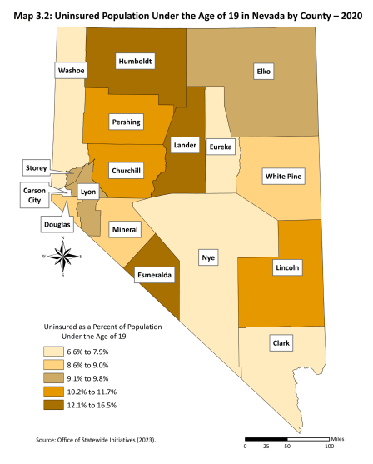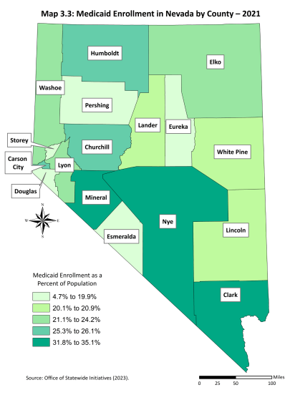
Source: Nevada Rural and Frontier Health Data Book – Eleventh Edition Map 3.2, Map 3.3
- Compared to the majority of counties in the State of Nevada, Humboldt County has a higher percentage (12.4%) of residents under the age of 19 who are uninsured (Nevada Rural and Frontier Health Data Book, Table 3.4)
- The percentage of Humboldt County population enrolled in Medicaid is 25.3%, or 1 in 4 residents (Nevada Rural and Frontier Health Data Book, Table 3.6)
The primary industries in Humboldt County are Agriculture and Agricultural Services, Mining, and Tourism and Construction. The region is home to several gold and silver mines, and agriculture is a major contributor to the local economy, with ranching, farming, and dairy operations. The county also attracts visitors for outdoor recreation activities such as hunting, fishing, and camping.
The Frontier Community Coalition Comprehensive Community Prevention Plan (FCCCCPP), which includes Humboldt, Pershing, and Lander counties, notes that due to the nature of work in these primary industries, many people in the region work long hours on extended schedules of days on and days off, which can lead to “family and community disorganization” (FCCCCPP, p. 7).

Additionally, one Humboldt County provider shared the following:
“The biggest employer is the mine, so many of our clients will have insurance, but it’s a high deductible plan, so people cannot afford to pay for services. They are underinsured, or not insured, and then for those on Medicaid the reimbursement is too low to cover our costs.”
Figure 1.2.4 Highest Level of Educational Achievement by Region (Frontier Community Coalition Service Area, State of Nevada, United States)
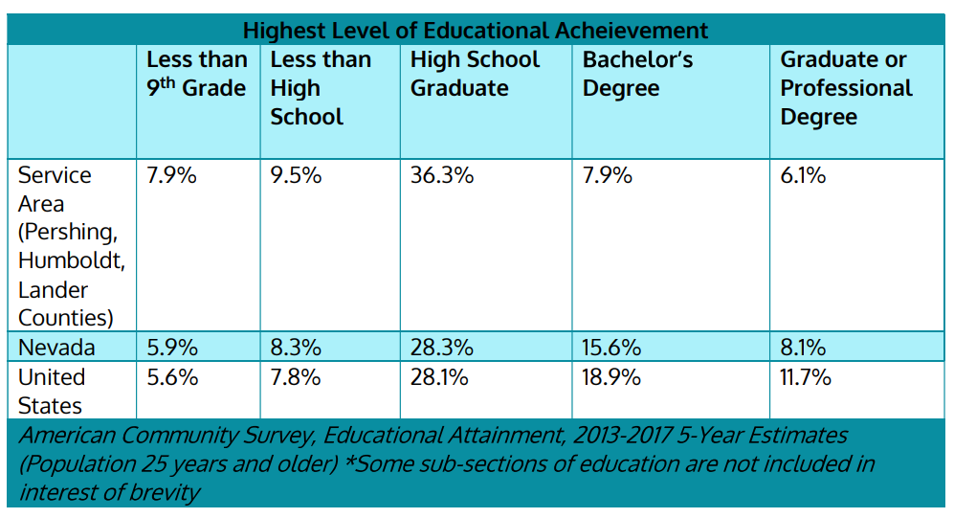
Source: Frontier Community Coalition Community Prevention Plan 2020-2023, p. 49.
Educational Achievement can have an impact of prevention efforts, as well as substance use. For the region, the educational attainment rates for those whose highest level of educational achievement is Less than 9th Grade and Less than High School is higher than the State and National rates.

1.3 Humboldt County Population Health Profile

In 2022, Humboldt County ranked 12th of the 17 counties in the State of Nevada for overall health outcomes and 11th in the State for overall health factors according to the County Health Rankings and Roadmaps (University of Wisconsin Population Health Institute). Health outcomes impacting these rankings include Length of Life and Quality of Life measures. Regarding Quality of Life measures, 21% of Humboldt County adults reported that they consider themselves in fair or poor health, which is a higher measure of poor health than both the national average (17%) and State average (20%). In Humboldt County, adults reported that their physical health was not good on 4.4 of the previous 30 days and their mental health was not good on 4.7 of the previous 30 days.
Health behaviors that negatively impact overall health factor rankings in Humboldt County include the prevalence of adult smoking (19% of adults compared to 15% in Nevada, 16% nationally) and adult obesity (36% of adults compared to 31% in Nevada, and 32% nationally).
Social and economic factors, as well as the physical environment, have an impact on the health of a population. In Humboldt County, unemployment is relatively low (4.9%) and the number of social associations (8.9 membership organizations per 10,000 people) is higher than the State average (4.3 orgs/100,000 people), both of which are factors that improve Humboldt County’s health factors ranking. Additionally, air pollution in Humboldt County (annual average of 6.4 micrograms per cubic meter of fine particulate matter in the air) is lower than the State and National average, and well below the Environmental Protection Agency (EPA) primary annual average standards of 12.0 micrograms per cubic meter.
All health profile data shared above and additional measures can be accessed through the County Health Rankings and Roadmaps published through the University of Wisconsin Population Health Institute.
Service requests made through the Nevada 2-1-1, part of a national network of call centers that provides information and referrals to services, for Humboldt County in May of 2020 show that Housing and Shelter was the most requested assistance (23 calls), followed by Healthcare (21 calls), Utilities (12 calls), Food (10 calls), and Transportation Assistance (10 calls). 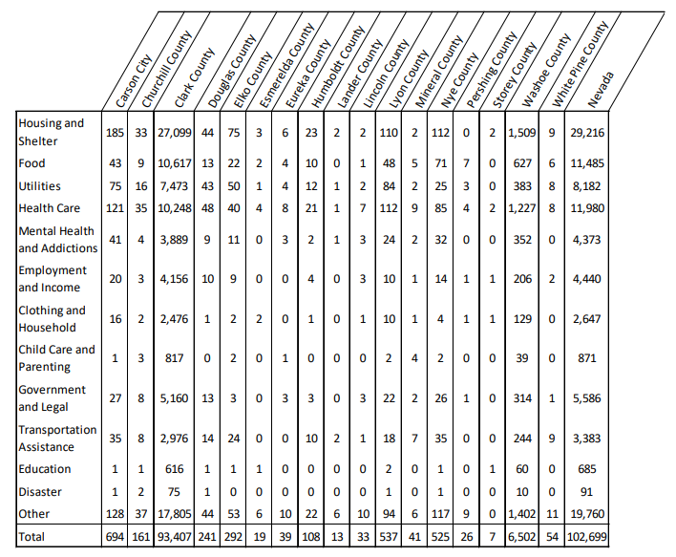
Figure 1.3.1 Nevada 2-1-1 Calls by County and Service Request, May 2020

Source: Substance Use Disorder & Opioid Use Disorder in Nevada: Policy Analysis and Infrastructure Assessment Report, Nevada Department of Health Care and Financing Policy, December 2020, Updated Version 3, p. 86.

Section 2: Methodology

2.1 Humboldt County Opioid Needs Task Force
Humboldt county convened an Opioid Needs Task Force of the County Commission October of 2022 and appointed Pauline Salla, Director of Juvenile Services, to lead the effort. The Task Force met on a monthly basis and the meetings were open to the public, accessible in person and via zoom. The Task Force included representation from the following agencies/organizations/leaders:
6th Judicial District Court | Nevada Division of Investigations
Humboldt County Juvenile Services | Family Support Center
Humboldt County School District | Humboldt County Human Services
Humboldt County Commission | Humboldt County District Attorney’s Office
Humboldt County Comptroller | Winnemucca Police Department
Humboldt County Justice Court | Division of Parole and Probation
Fort McDermitt Wellness Center | Frontier Community Coalition
Nevada Gold Mines | Person with Lived Experience

The task force engaged the support of the Nevada Association of Counties Public Health Coordinator to develop the assessment report, collect secondary quantitative data, and coordinate support with the State of Nevada Department of Health and Human Services Clinical Program Manager 3 and Mercer Government Human Services Consulting (Mercer), the State-contracted provider of technical assistance to counties for Opioid Needs Assessments and Plans.

2.2 Qualitative Data Collection/Community-Based Participatory Research
The Humboldt County Opioid Task Force convened a Community Opioid Needs Assessment Summit in April of 2023. The summit was open to all members of the community and pre-registration was circulated in advance through Humboldt County websites and news outlets. The summit panels focused on bringing perspectives from the following sectors in the community: (1) Health, Wellness & EMS; (2) Individuals with Lived Experience; (3) Law Enforcement; and (4) Business & Mining. The summit also included presentations from the Drug Enforcement Administration (DEA) on the prevalence, manufacture, and trafficking of fake synthetic opioids designed to look like pharmaceuticals, as well as an update from the State of Nevada Attorney general’s office on opioid litigation funding. The summit ended with training for all participants on the administration of naloxone and fentanyl testing strips. There were 119 attendees from across Humboldt County.

The following agencies/organizations/sectors/perspectives were represented:
Emergency Medical Services | Humboldt County Manager & Assistant Manager
Medical/Hospital | Sheriff’s Office
Bureau of Indian Affairs | Winnemucca Police Department
McDermitt Tribal Clinic | Division of Parole and Probation
Faith-Based Community | Nevada Division of Investigations
Humboldt County School District | Juvenile Services
Humboldt County Commission | Specialty Court – District Court
Winnemucca City Council | Medication Assisted Treatment (MAT) Provider
Family Support Center | Family Members who lost someone to Opioid Overdose
Great Basin Newspaper | Individuals in active recovery from opioid use/misuse
Private Defense Attorney | Division of Child and Family Services
Human Services | Hecla Mine
Winnemucca Domestic Violence | Nevada Gold Mines
Frontier Community Coalition | Community Health Nurse
Frontier Community Action Agency | NACO
Private Clinicians | LGBTQI+ Community
Law Enforcement | EMS
Medical and Hospital Employees | Senior Citizen Center employees
Ministerial Association | McDermitt Tribal Clinic
Division of Child and Family Services | School District
Private Clinicians | Humboldt Connections Suicide Prevention
Humboldt County School District | Adult Parole and Probation
Juvenile Services | Rural Mental Health
Community Business Owners | Mining Employees
Community Agencies | District Court
Justice Court | Adults currently in recovery
Youth currently in recovery | Frontier Action Agency
County Commissioners | Humboldt County Employees
City of Winnemucca Employees | Winnemucca Domestic Violence Services
Private Attorneys | District Attorney’s Office
Public Defenders Office | Self Help Population
NACO | Radio Stations
Local Newspaper | Youth Groups
Nevada Attorney General’s Office | Walmart
Substance Use Counselor | Members with Lived Experience

The Task Force distributed a community-wide survey to assess community awareness, perception of need, and recommendations. The Humboldt County Community Opioid Needs Survey collected 388 responses over a seven-week period (3/3/2023 – 4/21/2023). The survey included 10 questions. The responses illustrate the extent of the opioid crisis in Humboldt County, the community perception of critical issues to address, as well as the community knowledge surrounding prevention, treatment, and recovery. The survey was distributed to the public and to the following agencies/organizations:

Mercer Consulting analyzed and combined the community recommendations from both the summit and the survey into focus areas.

2.3 Quantitative Data Collection
The Task Force engaged community partners and agencies to share local data regarding opioid use/misuse and to compile a listing of current resources and assets. The Task Force also collected secondary quantitative data available through local, state, and national sources. The State of Nevada Office of Analytics supported the Task Force with county-level data visualizations. The following reports and sources were consulted for the secondary quantitative data collection:
- 6th Judicial District Specialty Court: Adult Drug Court Program
- 2020 Rural Behavioral Health Profile: Eureka, Humboldt, Lander, Pershing, and White Pine Counties, February 2021, Office of Analytics, Department of Health and Human Services, State of Nevada
- Behavioral Risk Factor Surveillance System (BRFSS) data presented in Behavioral Health Wellness and Prevention 2022 Epidemiologic Profile: Nevada Jan 2023
- County Health Rankings and Roadmaps: Humboldt County (University of Wisconsin Population Health Institute, 2023, Retrieved from: https://www.countyhealthrankings.org/explore-health-rankings/nevada/humboldt?year=2023
- Frontier Community Coalition Comprehensive Community Prevention Plan 2020-2023
- Nevada Rural and Frontier Health Data Book - 11th Edition January 2023
- Nevada State Unintentional Drug Overdose Reporting System https://nvopioidresponse.org/wp-content/uploads/2019/05/sudors_report_2019_2020.pdf
- Nevada Opioid Surveillance Hospital Profile – 2022 https://nvopioidresponse.org/wp-content/uploads/2022/12/Hospital-Profiles-508.pdf
- Nevada Youth Risk Behavior Surveillance System, 2015-2021, through the State of Nevada Department of Public and Behavioral Health and the University of Nevada Reno
- State of Nevada Office of Analytics Substance Use Surveillance Dashboard
  - Substance Related Dependence (All Substances and Opioid-Only) Emergency Department Encounters for Rural Behavioral Health Region
  - Substance Related Poisoning (All Substances and Opioid-Only) Emergency Department Encounters for Rural Behavioral Health Region
  - Substance Related Overdose Deaths (All Substances and Opioid-Only) for Rural Behavioral Health Region
- State of Nevada Office of Analytics Prescription Drug Monitoring Program (PDMP) Dashboard
  - Number and Rate of Opioid Prescriptions per 1,000 people for Humboldt County 2017-2023
  - Number and Rate of Buprenorphine Prescriptions per 1,000 people for Humboldt County 2017-2023
- State of Nevada Office of Analytics Unified Nevada Information Technology for Youth (UNITY) Database through the Division of Child and Family Services (DCFS)
  - Count of Drug or Alcohol Abuse-Related Tracking Characteristics Associated with CPS reports for Humboldt County 2017-2021
  - Children Under Age 1 Removed to Foster Care due to Parental Drug Use
- Substance Use Disorder & Opioid Use Disorder in Nevada: Policy Analysis and Infrastructure Assessment Report, Nevada Department of Health Care and Financing Policy, December 2020, Updated Version 3
- Overdose Detection Mapping Application Program (ODMAP)
- Humboldt County Juvenile Services

Section 3: Quantitative Data: Opioid Use Prevalence, Impact, and Risk Factors

The State of Nevada Department of Health and Human Services Office of Analytics provides electronic data dashboards on current status and trends related to substance use in Nevada separated into three categories collected from three different data sources: dependence (date source: hospital emergency department/room encounters), poisoning (data source: hospital inpatient admissions), and death (data source: the Division of Public and Behavioral Health’s Office of Vital Records electronic death registry system). The data is available by Behavioral Health Region. Humboldt County is included in the Rural Behavioral Health Region (Elko, Eureka, Humboldt, Lander, Pershing, and White Pine Counties).

3.1 Substance Related Dependence
Figures 3.1.1 and 3.1.2 below show key metrics for the Rural Behavioral Health Region in 2021 as well as the trend in rate count of emergency department visits with substance related dependence from January 2010 – December 2021 for the region. They demonstrate an increase in emergency room visits for all substances (Fig. 3.1.1) and opioids, specifically (Fig. 3.1.1). Note that these are based on diagnosis and may underrepresent the total number of emergency room visits for opioids in cases where individuals may not receive an opioid dependence diagnosis during their visit despite opioids prompting the emergency.

Figure 3.1.1 Substance Related Dependence (All Substances) – Emergency Department Encounters, Rural Behavioral Health Region
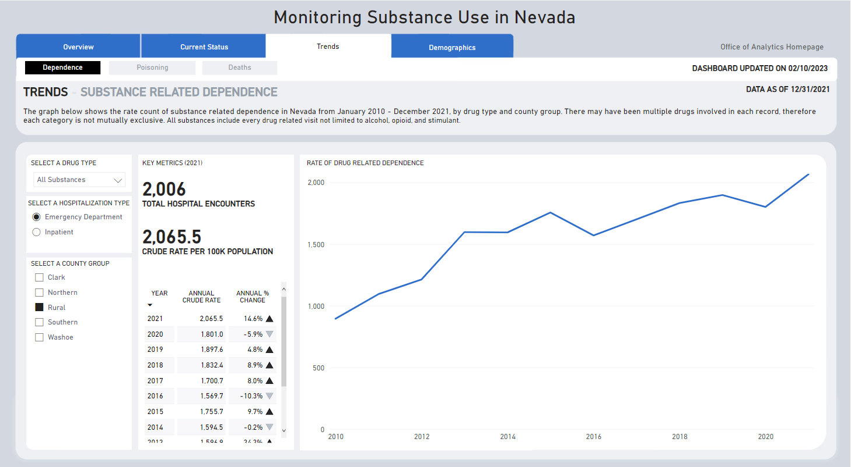
Source: State of Nevada Office of Analytics Substance Use Surveillance Dashboard https://app.powerbigov.us/view?r=eyJrIjoiODQ2MjJjMjktOWE5NC00MThmLTlkMmEtYzZjMDU0YWU3MmUyIiwidCI6ImU0YTM0MGU2LWI4OWUtNGU2OC04ZWFhLTE1NDRkMjcwMzk4MCJ9
Figure 3.1.2 Substance Related Dependence (Opioid) – Emergency Department Encounters, Rural Behavioral Health Region
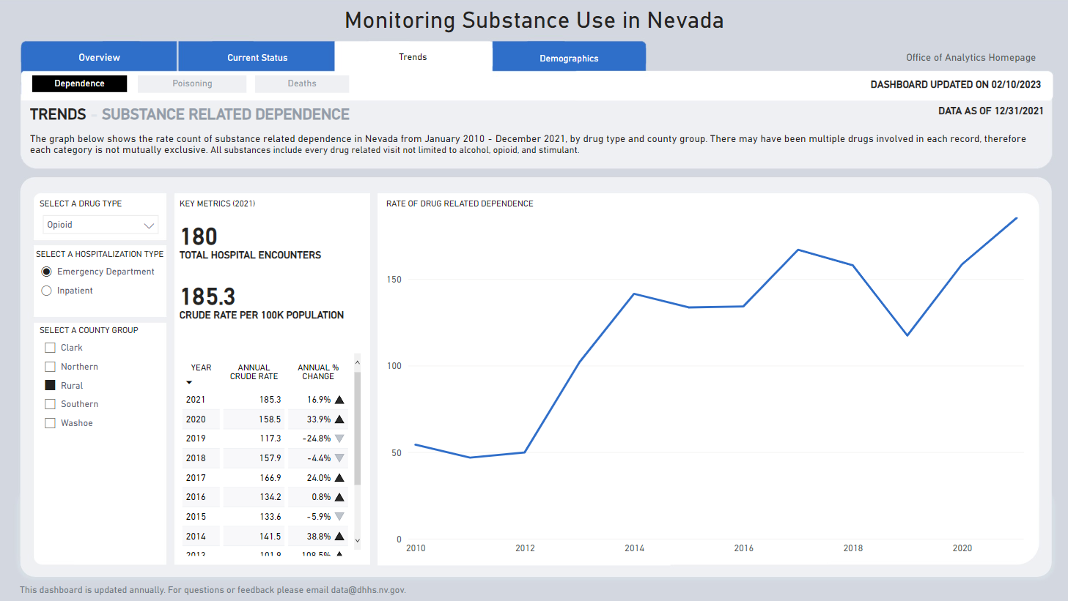
Source: State of Nevada Office of Analytics Substance Use Surveillance Dashboard https://app.powerbigov.us/view?r=eyJrIjoiODQ2MjJjMjktOWE5NC00MThmLTlkMmEtYzZjMDU0YWU3MmUyIiwidCI6ImU0YTM0MGU2LWI4OWUtNGU2OC04ZWFhLTE1NDRkMjcwMzk4MCJ9

Figure 3.1.3 Nevada Opioid Surveillance Hospital Profile – 2022, Humboldt General Hospital Opioid Poisoning ED Visits and Opioid-Related Inpatient Visits*
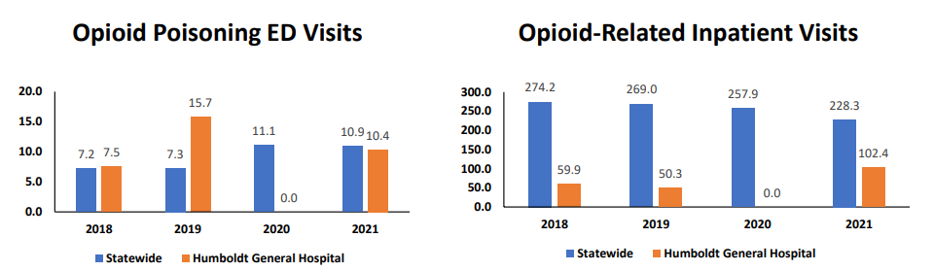
Source: Nevada Opioid Surveillance Hospital Profile – 2022, accessed: https://nvopioidresponse.org/wp-content/uploads/2022/12/Hospital-Profiles-508.pdf
*Rates per 10,000 patients for opioid overdose ED visits and opioid-related inpatient encounters for facility and statewide in NV.
Figure 3.1.4 Nevada Opioid Surveillance Hospital Profile – 2022, Humboldt General Hospital Percentage breakdown of demographics of opioid overdoses ED visits and opioid-related inpatient encounters for Humboldt General Hospital
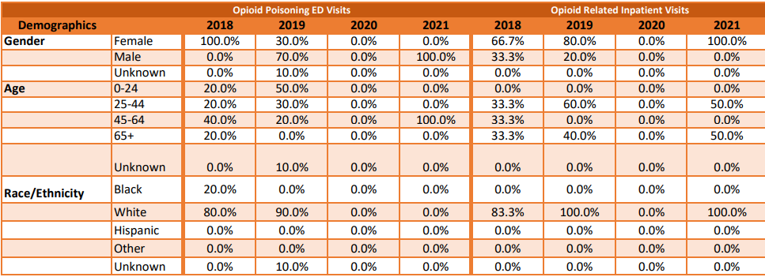
Source: Nevada Opioid Surveillance Hospital Profile – 2022, accessed: https://nvopioidresponse.org/wp-content/uploads/2022/12/Hospital-Profiles-508.pdf

When compared with other behavioral health regions, only the Rural Region shows an upward trend between 2016 and 2021. Other counties and regions saw a spike in 2016 but have either trended downward consistently or had a slight uptick after 2020, but none other than the Rural region have increased beyond the rates in 2016 (Fig. 3.1.2). This indicates that prior efforts at opioid mitigation may not have been successful in rural areas and additional work and resources tailored to these rural counties are needed. Additionally, the rates of ED encounters with opioid dependence diagnoses highlight a need for more access to opioid specific treatment and better coordination of care in order to potentially avoid emergency room encounters. Emergency rooms are not set up to treat opioid disorders, so more community-based resources are needed from prevention through treatment and recovery.

3.2 Substance Related Poisoning
Figures 3.2.1 and 3.2.2 below show key metrics for opioid and other substance related poisoning in emergency departments in the Rural Behavioral Health Region in 2021 as well as the trend in rate count of substance and opioid-related poisoning in the region from January 2010 – December 2021.
Figure 3.2.1 Substance Related Poisoning (All Substances) – Emergency Department Encounters, Rural Behavioral Health Region
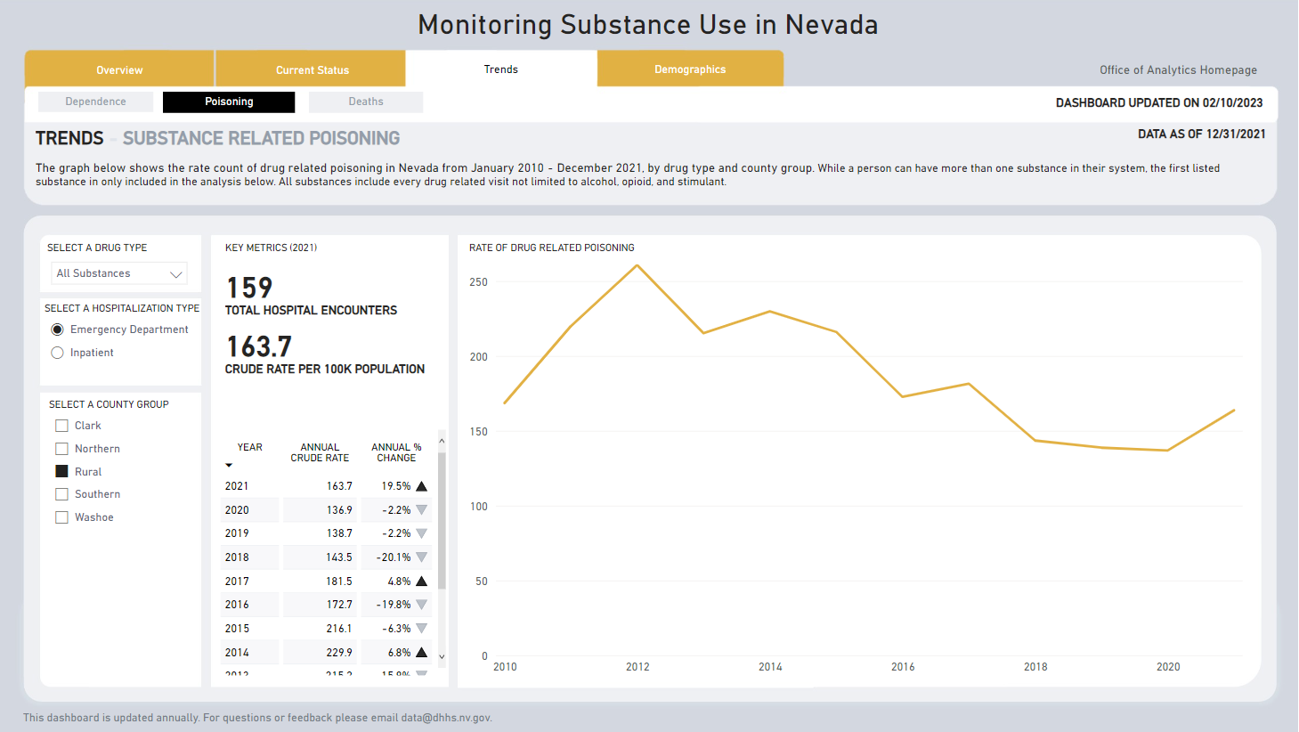
Source: State of Nevada Office of Analytics Substance Use Surveillance Dashboard https://app.powerbigov.us/view?r=eyJrIjoiODQ2MjJjMjktOWE5NC00MThmLTlkMmEtYzZjMDU0YWU3MmUyIiwidCI6ImU0YTM0MGU2LWI4OWUtNGU2OC04ZWFhLTE1NDRkMjcwMzk4MCJ9In :
In 2018, Emergency Department visits and hospitalizations for all opioids except heroin were highest for those aged 15 to ‍24 years in Humboldt County. [1]
Compare this to youth referred to Juvenile Services during this same time period for youth aged 15-18 years, only two youth out of over 300 referrals reported opioid substance use or tested positive for opioids through their time of involvement with any level of supervision.
This finding allows Humboldt County to explore this age group and demographics in more depth during the next three years to identify which systems may potentially come into contact with this age group to identify gaps and barriers to access to services.
[1] Nevada Division of Health Care Financing and Policy, Substance Use Disorder & Opioid Use Disorder in Nevada: Policy Analysis and Infrastructure Assessment Report, 2020.

Figure 3.2.2 Substance Related Poisoning (Opioid) – Emergency Department Encounters, Rural Behavioral Health Region
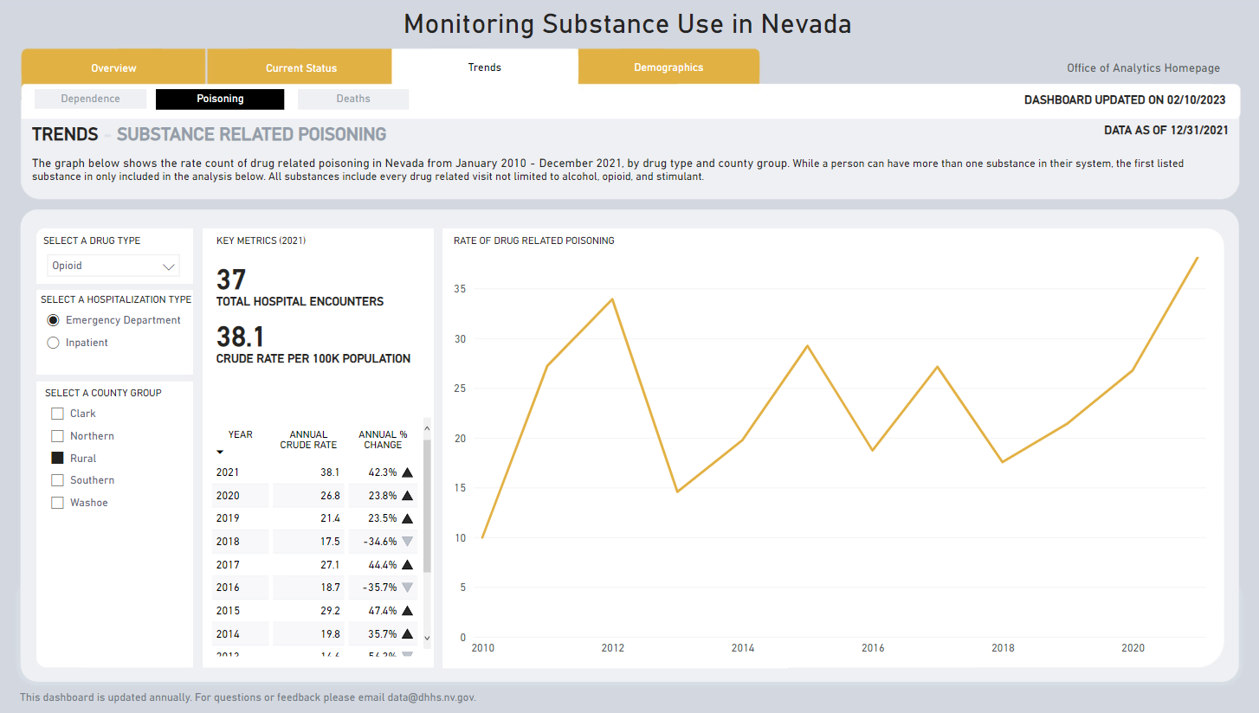
Source: State of Nevada Office of Analytics Substance Use Surveillance Dashboard https://app.powerbigov.us/view?r=eyJrIjoiODQ2MjJjMjktOWE5NC00MThmLTlkMmEtYzZjMDU0YWU3MmUyIiwidCI6ImU0YTM0MGU2LWI4OWUtNGU2OC04ZWFhLTE1NDRkMjcwMzk4MCJ9

Opioid poisoning rates have increased since 2018 despite poisoning from other substances flat or slowly rising. Opioid overdose rates spiked in 2020. These findings demonstrate the need for harm reduction (naloxone), prevention/education, and recovery supports (for relapse overdoses).

Data retrieved from Humboldt General Hospital from 2021, Opioid poisoning visits to the Emergency Department was similar to the statewide rate of 10.9, with Humboldt County’s 10.4 rate. In 2019, Humboldt County’s rate of Emergency Department visits was over two times the state rate, with Humboldt County at 15.7 incidents per 10,000 individuals while the state was at 7.3 incidents per 10,000 individuals. Although more work is needed, this may provide support that strategies implemented in the last few years have provided some success in the opioid epidemic across age groups.

3.3 Substance Related Overdose Deaths
Figures 3.3.1 and 3.3.2 below show substance and opioid-related overdose deaths for the Rural Behavioral Health Region in 2021 as well as the trend in rate count of substance and opioid-related poisoning in the region from January 2010 – December 2021.

Figure 3.3.1 Substance Related Overdose Deaths (All Substances) – Rural Behavioral Health Region
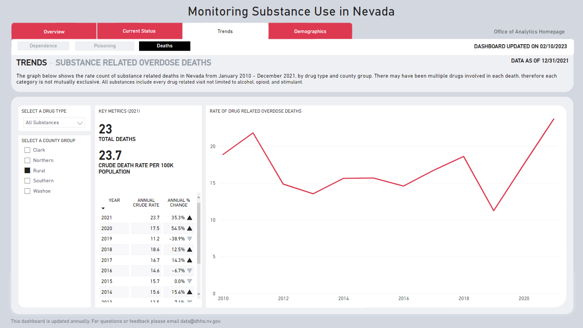
Source: State of Nevada Office of Analytics Substance Use Surveillance Dashboard https://app.powerbigov.us/view?r=eyJrIjoiODQ2MjJjMjktOWE5NC00MThmLTlkMmEtYzZjMDU0YWU3MmUyIiwidCI6ImU0YTM0MGU2LWI4OWUtNGU2OC04ZWFhLTE1NDRkMjcwMzk4MCJ9

Polysubstance overdoses, including stimulants, nearly doubled from 2019 to 2020, indicating that stimulants are a growing concern along with opioids. In 2021, the rural region saw an increase of 35.3% in polysubstance deaths than 2020. This provides a reminder that as we address the opioid epidemic, we remain vigilant in our work with all substances.

Figure 3.3.2 Substance Related Overdose Deaths (Opioid) – Rural Behavioral Health Region
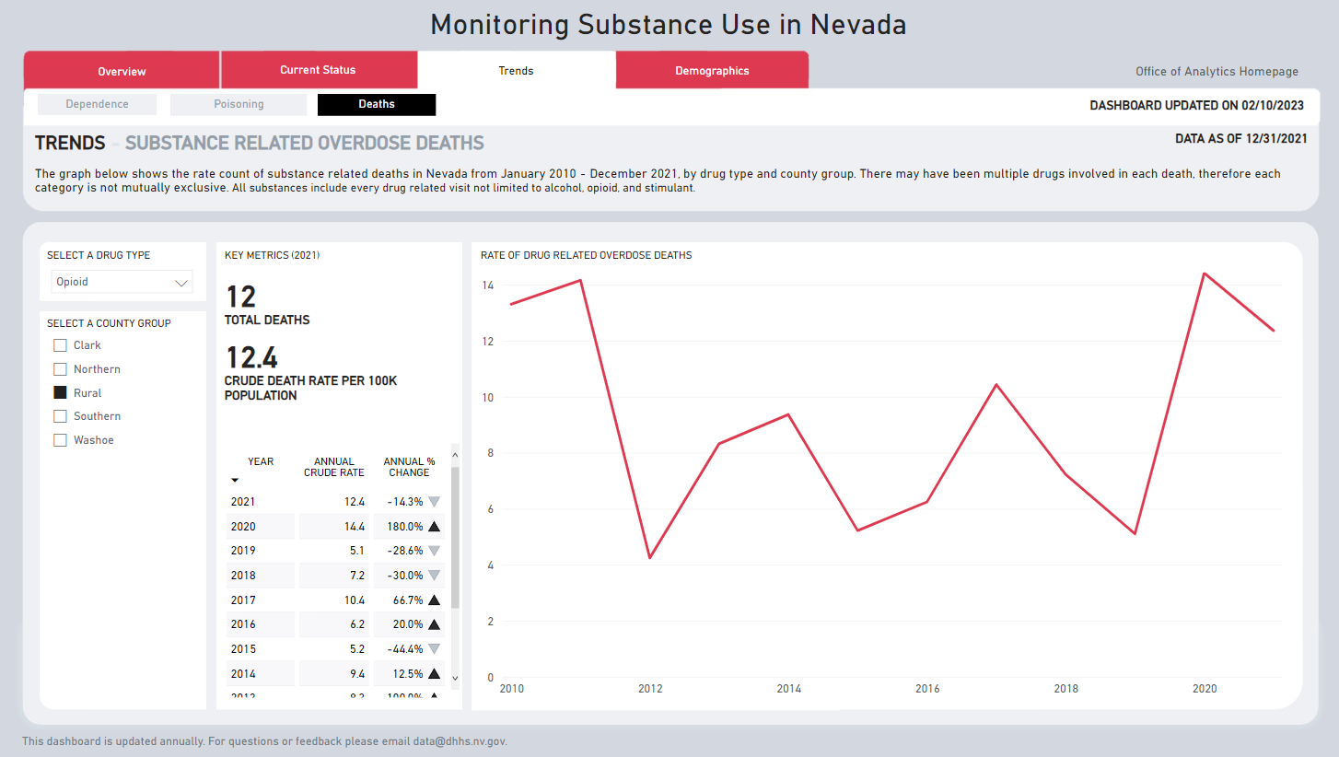
Source: State of Nevada Office of Analytics Substance Use Surveillance Dashboard https://app.powerbigov.us/view?r=eyJrIjoiODQ2MjJjMjktOWE5NC00MThmLTlkMmEtYzZjMDU0YWU3MmUyIiwidCI6ImU0YTM0MGU2LWI4OWUtNGU2OC04ZWFhLTE1NDRkMjcwMzk4MCJ9

In additional to the increase in substance-related overdose deaths for the rural region reported above, Douglas, Humboldt, Pershing, and Lander counties all reported increases in the rate of opioid-related overdoses in 2020 (State of Nevada Department of Health and Human Services, Nevada State Unintentional Drug Overdose Reporting System: Report of Deaths 2019 to 2020 – Statewide 2020. Available at: https://nvopioidresponse.org/wp-content/uploads/2019/05/sudors_report_2019_2020.pdf)

Figure 3.3.3 Drug-Related and Opioid-Related Overdose Death Rates, Humboldt and Surrounding Counties
County | Drug-Related Overdose Death Rates |  |  | Opioid-Related Overdose Death Rates
 | 2019 | 2020 | Change | 2019 | 2020 | Change
Elko | 5.5 | 12.7 | ↑ 7.2 | 1.8 | 12.7 | ↑ 10.9
Eureka | — | — | — | — | — | —
Humboldt | 29.3 | 17.6 | ↓ 11.7 | 11.7 | 17.6 | ↑ 5.9
Lander | — | 33.4 | ↑* | — | 33.4 | ↑*
Pershing | — | 14.4 | ↑* | — | 14.4 | ↑*
White Pine | 28.3 | 28.4 | ↑ 0.1 | 18.8 | 9.5 | ↓ 9.3
Source: As reported in State of Nevada Opioid Needs Assessment with data pulled from Suspected Nevada Drug Overdose Surveillance Monthly Report January 2022, Statewide Report. Data include accidental poisonings, intentional self-poisonings, and assault by drug poisonings, and drug poisoning of undetermined intent for drug-related overdose deaths and where any of the following opioid-related substances contributed to the cause of death: opium, heroin, natural and semi-synthetic opioids, methadone, synthetic opioids, and other/unspecified opioids. Note: “—” indicates data where the rate may be 0 or was suppressed due to low counts. “*” indicates a change in the rate could not be calculated

Data shows that drug related and opioid related overdose death rates have increased across several rural jurisdictions. This may be due to lack of capacity for higher level of treatment, limited MAT providers or other responsivity factors

3.4 ODMAP Data for Humboldt County

ODMAP (Overdose Detection Mapping Application Program) provides real-time data on suspected opioid overdose, suspected fatal overdose, and administration of naloxone in cases of suspected opioid overdose. The data is collected through the state Emergency Medical Services (EMS) database and pulled into ODMAP. Complete data sets are available starting from November of 2020. Data from November 2022 through March 2023 is presented to provide as recent a snapshot as possible of suspected overdoses in Humboldt County. As data for ODMAP is collected from the state EMS database, it is likely to be an underreporting of suspected overdoses and should be considered together with other datasets. For example, if someone experiencing an overdose is taken directly to a hospital by a community member, or a community member administers naloxone to a peer without EMS intervention, those overdoses will not be reflected in the ODMAP tool.

Figure 3.4.1 ODMAP Data for Humboldt County
 | 11/1/20-10/31/21 | 11/1/21-10/31/22 | 11/1/22-3/31/23  (5 months only)
Total Suspected Overdoses | 41 | 38 | 26
Suspected Fatal Overdoses | 6 | 6 | 0
Naloxone | 13 | 14 | 8
Source: ODMAP database
Data extracted on: June 1, 2023
Prepared by: Comprehensive Opioid, Stimulant, and Substance Use Program (COSSUP), State of Nevada Office of the Attorney General

Figure 3.4.2 ODMAP Data for Humboldt County Heat Map 11/1/20-10/31/2021
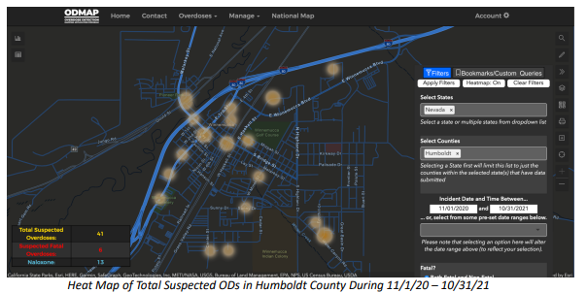 Source: ODMAP database
Data extracted on: June 1, 2023
Prepared by: Comprehensive Opioid, Stimulant, and Substance Use Program (COSSUP), State of Nevada Office of the Attorney General

Figure 3.4.3 ODMAP Data for Humboldt County Heat Map 11/1/21-10/31/2022
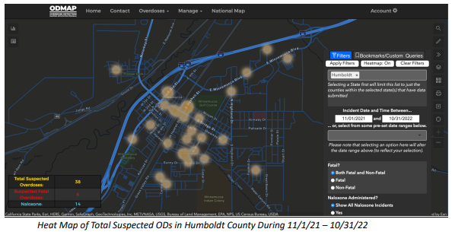
Source: ODMAP database
Data extracted on: June 1, 2023
Prepared by: Comprehensive Opioid, Stimulant, and Substance Use Program (COSSUP), State of Nevada Office of the Attorney General

Figure 3.4.4 ODMAP Data for Humboldt County Heat Map 11/1/22-3/31/2023
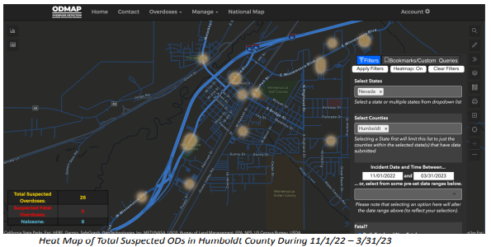
Source: ODMAP database
Data extracted on: June 1, 2023
Prepared by: Comprehensive Opioid, Stimulant, and Substance Use Program (COSSUP), State of Nevada Office of the Attorney Genera

3.5 Opioid Prescribing
The State of Nevada Office of Analytics monitors the Prescription Drug Monitoring Program (PDMP) in Nevada. The PDMP tracks controlled substance prescriptions across the state. The more prescriptions that are available, the higher the chances that they may be overused or diverted. Prescribers who prescribe only what is needed for each individual patient can prevent diversion by minimizing leftover medication circulating in communities.
Figure 3.5.1 Rate of Opioid Prescriptions by Humboldt and Surrounding Counties
County | Rate per 100 Persons | Difference between County and State Rate* | Difference between County and National Rate*
White Pine | 28.6 | −18.8 | −14.7
Elko | 25.2 | −22.2 | −18.1
Pershing | 14.9 | −32.5 | −28.4
Humboldt | 9.7 | −37.7 | −33.6
Eureka | 8.2 | −39.2 | −35.1
Lander | 1.7 | −45.7 | −41.6
Source: Nevada Opioid Needs Assessment and Statewide Plan 2022, State of Nevada Department of Health and Human Services, Dec. 1 2022, p. 13-14. Compared to the State rate, Humboldt and surrounding counties have some of the best rates in the rate. More consideration should be given to understanding this success rate to ensure continued success (i.e. is it education, training, and support from local physicians, or other) and ensure there are no gaps (for example, patients may be seeking care outside of the county).
Figure 3.5.2 Patient County Trends: Number and Rate of Opioid Prescriptions per 1,000 people for Humboldt County (data for 2023 are preliminary), 2017-2023
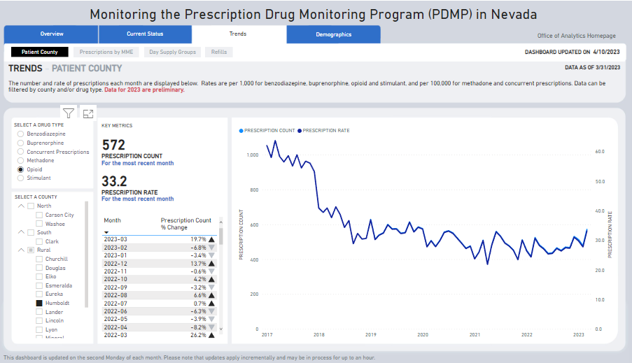
Source: State of Nevada Office of Analytics Monitoring the Prescription Drug Monitoring Program (PDMP) in Nevada https://app.powerbigov.us/view?r=eyJrIjoiYjgyYzkyMzctNDg0OS00ZGY1LWJiMWYtM2E0NDlkZjI0MmEyIiwidCI6ImU0YTM0MGU2LWI4OWUtNGU2OC04ZWFhLTE1NDRkMjcwMzk4MCJ9
Figure 3.5.3 Patient County Trends: Number and Rate of Buprenorphine Prescriptions per 1,000 people for Humboldt County (data for 2023 are preliminary), 2017-2023
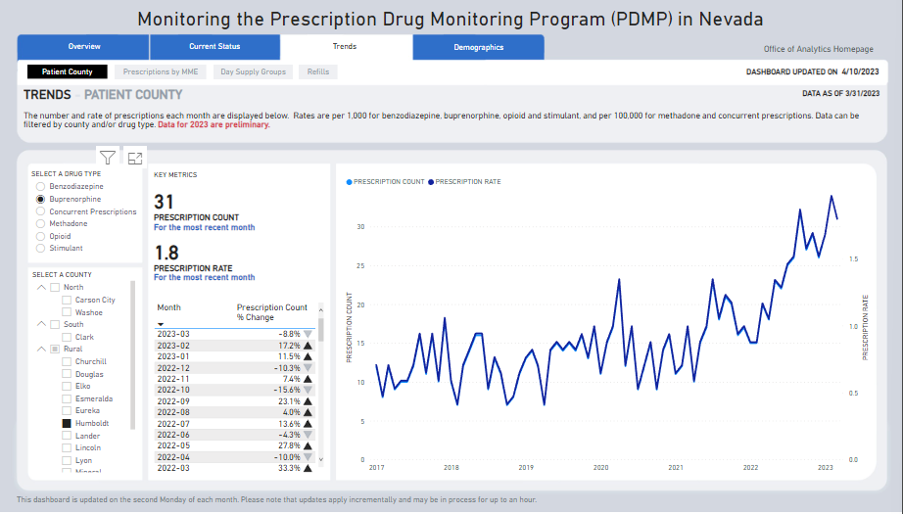
Source: State of Nevada Office of Analytics Monitoring the Prescription Drug Monitoring Program (PDMP) in Nevada https://app.powerbigov.us/view?r=eyJrIjoiYjgyYzkyMzctNDg0OS00ZGY1LWJiMWYtM2E0NDlkZjI0MmEyIiwidCI6ImU0YTM0MGU2LWI4OWUtNGU2OC04ZWFhLTE1NDRkMjcwMzk4MCJ9

Buprenorphine is used for opioid addiction to reduce cravings and withdrawal symptoms without causing euphoria or dangerous side effects and helps prevent relapse. It works by being a substitute for the drug being abused, so the patient has minimal discomfort, which allows the patient to focus on their recovery. Buprenorphine for OUD is used as part of a complete treatment program that also includes counseling and behavioral therapy.
Data trend show MAT treatment has increased since 2021 which supports harm reduction efforts in Humboldt County.

Figure 3.5.4 Patient County Trends: Number and Rate of Methadone Prescriptions per 100,000 people for Humboldt County (data for 2023 are preliminary), 2017-2023
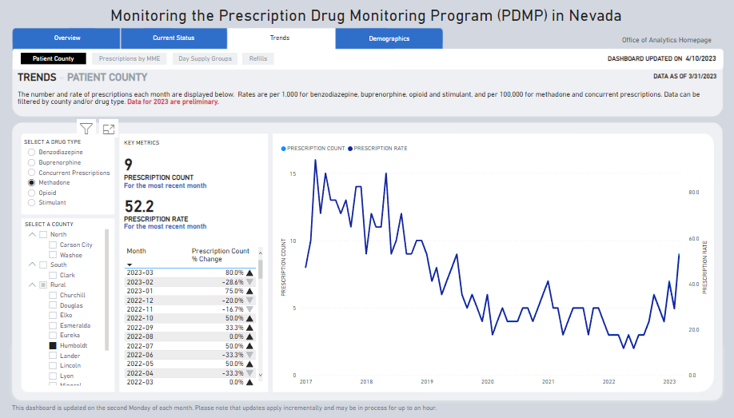
Source: State of Nevada Office of Analytics Monitoring the Prescription Drug Monitoring Program (PDMP) in Nevada https://app.powerbigov.us/view?r=eyJrIjoiYjgyYzkyMzctNDg0OS00ZGY1LWJiMWYtM2E0NDlkZjI0MmEyIiwidCI6ImU0YTM0MGU2LWI4OWUtNGU2OC04ZWFhLTE1NDRkMjcwMzk4MCJ9

Methadone is a long-acting opioid medication that is used to reduce withdrawal symptoms in people addicted to heroin or other narcotic drugs, and it can also be used as a pain reliever. When methadone is used for OUD it reduces withdrawal symptoms and drug cravings, but does not cause the "high" associated with the drug addiction. Methadone is highly regulated medication (Schedule 2 Controlled Substances Act) and when used for OUD is only available through approved opioid treatment programs (OTP) that involves regular monitoring, counseling, and drug testing to make sure that patients are making progress in their recovery

3.6 Opioid Use and Adult Drug Court Utilization
The Sixth Judicial District Court serving Humboldt County includes a general jurisdiction court as well as five specialty courts, including an Adult Drug Court (ADC), DUI Court, and Juvenile Diversion Court. The Adult Drug Court intake data demonstrates an increase in the percentage of new participants admitted to the program who have a diagnosis of Opioid Use Disorder (OUD).
Figure 3.6.1 Percentage of new participants in 6th Judicial District Adult Drug Court who have an Opioid Use Disorder Diagnosis by Year
 | 2020 | 2021 | 2022
Percentage of new participants in 6th Judicial ADC who have an Opioid Use Disorder Diagnosis | 30% | 63.3% | 71.41%
Source: 6th Judicial District Court, Humboldt County, provided 5/11/2023 through Adult Drug Court Program Coordinator
Additionally, the ADC Program Coordinator also reports that new participants are having a higher recommended level of care at intake than in years prior. From March 2022 to March 2023, 66% of participants admitted into the program had an inpatient treatment recommendation at intake.
“Although we have substance use treatment providers to provide outpatient treatment locally we do not have withdrawal management or inpatient treatment in the community. We have a drug court that is often able to assist with transportation to this level of care, but the community would greatly benefit from having these services locally.”
There is evident need for more treatment for those entering drug court to keep up with demand and to have access to the correct level of care for individuals in need of inpatient treatment. Strategic planning could include the development of an inpatient facility that treats both mental health and substance use/misuse disorders with nearby counties to meet the needs of each community. Additionally, providing access to any of these services prior to law enforcement or court involvement allows all communities the opportunities for treatment.
Figure 3.6.2 Participants in 6th Judicial District Family Treatment Court who have an Opioid Use Disorder Diagnosis, Recommendation for Inpatient Treatment by Year
 | 2020 | 2021 | 2022 | 2023 (Jan-May)
Count of Participants with Opioid Use Disorder | 4 | 5 | 4 | 2
Count of Participants with Recommendation for Inpatient Treatment | 3 | 4 | 2 | 4
Total Admissions | 15 | 21 | 13 | 7

Additionally, the Family Treatment Court Coordinator shared the following:
“Family Treatment Court prioritizes timely access to treatment and strives to have clients evaluated and connected to treatment within 30 days of first contact. In federal fiscal year 2022, the average time to substance use treatment was 16 days. However, the average time to mental health treatment was 72 days. Identified barriers to treatment included availability of service providers and long wait times.
Although Family Treatment Court recognizes that a continuum of care is often needed to treat substance use disorders, we continue to struggle with only one level of care being offered locally (outpatient). We have created partnerships with other service providers outside of the area, but transportation barriers create a delay in accessing these services in areas where additional levels of care are available. Housing and childcare also continue to be a barrier as well to both substance use recovery and family reunification efforts.
Anecdotally, we also hear from clients a concern for their recovery after they complete programming. In areas like Humboldt County where services are limited, formal treatment services are often focused on triaging the highest risk needs of the community, but efforts/services are still needed to prevent recidivism or reescalation of risk for those who have previously received formal treatment services in order to maintain recovery. Gaps in this area include limited mutual-help meetings, minimal peer support services, and few recovery-oriented places/activities locally for those in recovery to stay connected to.”

3.7 Opioid Statistics from the Tri-County Drug Enforcement Team (Tri-DENT)

The data below are from the Tri-County Drug Enforcement Team (Tri-DENT) which operates in Humboldt, Pershing, and Lander counties. The statistics below represent only the opioid cases from Humboldt County. These statistics are based upon the seizure of opioids to include prescription opioids, heroin, and fentanyl-based street drugs.
Figure 3.7.1 Total and Opioid-Specific Drug Seizures in Humboldt County by Year collected by the Tri-County Drug Enforcement Team (Tri-DENT)

 | Cases that involved a drug seizure, were opioids | Total cases that involved drug seizure | % of drug seizure cases that were opioids
2020 | 8 | 47 | 17%
2021 | 11 | 53 | 20.7%
2022 | 11 | 44 | 25%
2023 YTD  (thru 8/25/23) | 9 | 34 | 26.4%

In addition to the data above, the Tri-County Drug Enforcement team also shared the following:

“We have experienced a slight increase of opioid related cases over the past 3+ years. I believe our county shares this same common trend with other similarly sized counties across Nevada. The most predominately encountered drug is still methamphetamine, however we have seen a recent spike in cocaine. Rx diversion cases are almost non-existent, and marijuana related cases have obviously dropped off significantly with the recreational legalization.”

3.8 Humboldt County Detention Center Substance Use Data

The data below is from all agencies that book into the Humboldt County Detention Center. The standard practice on a drug offense booking is to book under NRS 453.366 possession of a controlled substance, so the booking data does not differentiate between drug type (methamphetamine, opioid, cocaine, etc.) Additionally, individuals may be booked on a charge other than possession of a controlled substance, but still have a substance use problem. From January to August 2023 there have been 393 total bookings.
The Detention Center team shared that drug-related bookings were significantly down in 2020-2021 (59 total bookings for Possession of a controlled substance) most likely from COVID-19 and the detention centers intake procedures during that time. In 2022, there were 84 bookings for possession of a controlled substance. From January to August 2023, there were already 46 bookings for possession of a controlled substance (11.7% of all bookings). Again, these numbers likely reflect an undercount of the prevalence of substance use among individuals booked into jail as they only reflect individuals booked with possession of a controlled substance.
In February of 2023, Humboldt County Detention Center began tracking data on individuals who admitted opioid use at booking. The data below shows the extent of opioid-use challenges within the detention center environment.
Figure 3.8.1 Individuals Admitting Opioid Use and Individuals Needing Additional Care/Observation due to Opioid Use at Humboldt County Detention Center, February to August 2023
 | Admitted Opioid Use at Booking | Required Additional Medical Attention or Observation (i.e. MAT prescription refill)
February | 3 | 2
March | 12 | 8
April | 15 | 11
May | 17 | 8
June | 9 | 6
July | 13 | 10
August | 5 | 3
Total | 74 | 48

3.9 Parental Substance Use
Parental substance use can have significant negative impacts on infants and children. Prenatal substance use during pregnancy has been shown to increase the risk of preterm birth, low birth weight, and developmental issues in infants (Behnke et al., 2013) and Neonatal Abstinence Syndrome (Patrick et al., 2012). Prenatal substance use can contribute to long-term cognitive and behavioral issues in children (Warner et al., 2017), and children of parents with substance use disorders are at a higher risk of developing substance use problems (2016). The Division of Child & Family Services within the Nevada Department of Health and Human Services collects data on substance exposed infants, and Child Protective Services (CPS) encounters involving substance use, as well as children removed to foster care due to parental drug use. The Humboldt County data is reported below. While the total counts of incidents may be low for some measures due to the overall population size, the potential short-term and lifelong impacts to even a single child or family and the impacts to the extended network of relations and supportive services surrounding that single child or family is extensive.

Figure 3.9.1 Prenatal Substance Use Birth Rates (Self-Reported) for Select Substances, Rural Region, 2010-2019
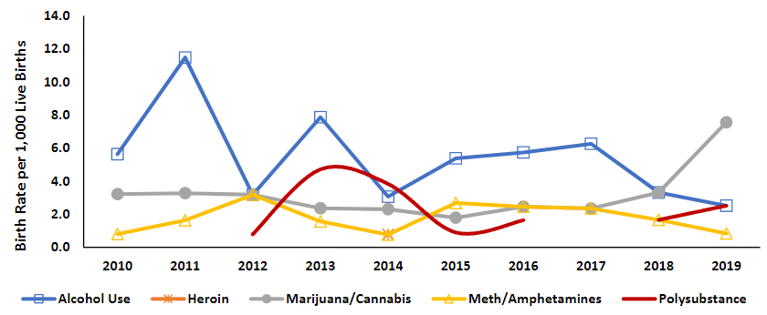
Source: 2020 Rural Behavioral Health Profile: Eureka, Humboldt, Lander, Pershing, and White Pine Counties, February 2021, pg. 37.

Figure 3.9.2 Neonatal Abstinence Syndrome, Rural Region, 2010-2019
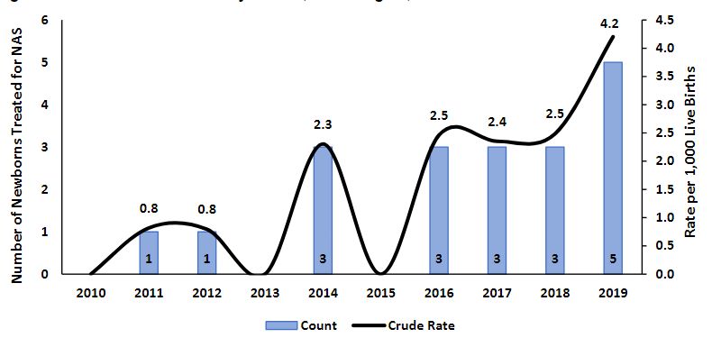
Source: 2020 Rural Behavioral Health Profile: Eureka, Humboldt, Lander, Pershing, and White Pine Counties, February 2021, pg. 38, utilizing Hospital Inpatient Department Billing and Nevada Electronic Birth Registry System.

Figure 3.9.3 Count of Drug or Alcohol Abuse-Related Tracking Characteristics Associated with CPS Reports Received by Calendar Year for Humboldt County 2017-2021

Source: UNITY* database
Data extracted on: February 23, 2022
Prepared by: Office of Analytics - DCFS Branch
UNITY stands for Unified Nevada Information Technology for Youth and is Nevada's Comprehensive Child Welfare Information System (CCWIS) which holds the
official case record for child welfare related case management activities in Nevada. This information system and its data are dynamic and constantly being modified or updated. Data reflected in these tables is accurate as of the data extraction date noted in the header.
Reports represent any CPS report received by calendar year indicated, regardless of final screening decision and subsequent agency response, with at least one drug or alcohol abuse-related tracking characteristic associated with the report.
The tracking characteristics counts do not represent the number of reports received in the CY because a single report could have multiple drug or alcohol- related tracking characteristics associated to the same report. Additionally, the counts show the use of tracking characteristics for all incoming CPS reports, regardless of whether the report was ultimately screened in or out.
The marijuana-related report tracking characteristics of MARIJUANA ABUSE and MARIJUANA EXPOSED INFANT were added to UNITY on 10-23-2015. The opioid- related report tracking characteristics of ILLEGAL OPIOID AUBSE, PRESCRIPTION OPIOID MISUSE/ABUSE, and OPIOID EXPOSED INFANT were added to UNITY on 7-20-2018.
The "county of occurrence" indicates where the alleged drug or alcohol abuse occurred. This became a required data entry field for all CPS referrals in 2017. Prior to that, this field did not exist in UNITY, so the county of occurrence was obtained from the referral zip code, which is the zip code of the primary caretaker associated with the CPS referral. Due to data quality issues with the referral zip code (invalid or missing zip codes) the county of occurrence may be blank. Referrals with valid zip codes which were outside of Nevada may be counted in the "OTHER" category.

Figure 3.9.4 Children Under Age 1 Removed to Foster Care due to Parental Drug Use by Calendar Year (CY), Humboldt County

Source: UNITY* database, AFCARS^ extract
Data extracted on: March 25, 2022
Prepared by: Office of Analytics - DCFS Branch
This table contains youth under age 1 removed to foster care in the year for any reason (youth may have multiple removal reasons). These counts reflect the foster care entry cohort for each year broken out by county.
The county in the data used for these summary tables is the county associated with the court responsible for the youth's foster care case. This is usually, but not always, the county of the youth's origin. The court responsible for the youth's foster care case is known from the court hearings associated with the youth's case.
The county may be blank for some youth if there is no court hearing entered into UNITY for the youth's foster care case.
This table contains youth under age 1 removed to foster care in the year indicated for the AFCARS removal reason of 'Parental Drug Use.' This category contains the following specific UNITY removal reasons: Parent's Drug Abuse, Parent's Meth Use, and Parent's Opioid Use. One or more of these specific UNITY removal reasons may be selected for the youth indicated as having the AFCARS removal reason of 'Parental Drug Use.'

3.10 Adult Risk Factor Prevalence
The Behavioral Risk Factor Surveillance System (BRFSS) is a survey conducted by the Centers for Disease Control and Prevention (CDC) that collects information on health behaviors, risk factors, and chronic conditions among adults in the United States. Monitoring the BRFSS data is a helpful tool for communities and stakeholders, including prevention coalitions, when planning interventions to reduce risky behaviors that may lead to increased substance use. The Behavioral Health Wellness and Prevention 2022 Epidemiologic Profile: Nevada published by the State of Nevada Department of Health and Human Services Office of Analytics provides BRFSS data by coalition region. Humboldt County is served by the Frontier Community Coalition (FCC), which also serves Lander County and Pershing County. The prevalence estimates for specific health indicators in this region are listed below. It is important to note that the BRFSS data relies on self-reported information and may not accurately reflect the true prevalence of illegal drug use in Nevada.
Figure 3.10.1 Prevalence Estimates of Health Risk Behaviors by FCC Coalition Region & State, Nevada Adults, 2021
Indicator | % FCC Region | % Nevada
Ever seriously considered attempting suicide during the past 12 months | 9.2% (0.1.-22.1) | 4.5% (3.2-5.8)
Heavy drinkers | 8.2% (1.0-15.3) | 4.6% (3.6-5.6)
Binge drinkers | 20.7% (5.1-36.3) | 11.9% (10.1-13.6)
General health poor or fair | 25.9% (9.6-42.1) | 18.5% (15.6-21.5)
Depressive disorder diagnosis | 12.1% (2.0-22.3) | 16.9% (14.9-18.9)
Ten or more days of poor mental health | 16.8% (0.0-34.8) | 20.7% (18.4-22.9)
Ten or more days of poor mental health or physical health kept from usual activities | 16.8 % (0.0-34.8) | 25.7% (22.6-28.9)
Use marijuana/hashish in the last 30 days | 36.4% (17.9-54.9) | 18.2% (15.8-20.5)
Used other illegal drugs in the last 30 days | 12.0% (0.0-26.2) | 2.8% (1.2-3.3)
Used prescription drugs without doctor’s order to get high in last 30 days | 0.0% (0.0-0.0) | 1.7% (0.7-2.7)
Current tobacco cigarette smokers | 18.0% (7.6-28.4) | 14.7% (12.7-16.7)
Difficulty doing errands alone because of physical, mental, or emotional condition | 9.7% (0.0-20.2) | 8.4% (6.8-10.0)
Serious difficulty concentrating, remembering, or making decisions because of physical, mental, or emotional condition | 12.0% (1.4-22.6) | 13.6% (11.7-15.5)
Source: Behavioral Risk Factor Surveillance System (BRFSS) data presented in Behavioral Health Wellness and Prevention 2022 Epidemiologic Profile: Nevada (Jan 2023), retrieved from: https://dhhs.nv.gov/Programs/Office_of_Analytics/OFFICE_OF_ANALYTICS_-_DATA___REPORTS/ p. 80.

Effective assessment of high-risk behaviors involves collecting data that aids policy makers, stakeholders and community members to quantify substance misuse, mental health crises, and suicidality. Our coalition regions have a higher rate compared to the state rate in 8 of the 13 data elements. Noteworthy is the domain of “Used other illegal drugs in the last 30 days”. Lander, Pershing and Humboldt County data shows a six-time higher rate than the statewide responses. Individuals contemplating suicide in the last twelve months was twice as high as the statewide rate.

3.11 Youth Risk Factor Prevalence
On behalf of the Nevada Department of Education and the Nevada Division of Public and Behavioral Health (DPBH), the University of Nevada, Reno's School of Public Health administers the Youth Risk Behavior Survey (YRBS). The YRBS is a survey of adolescent health behaviors and provides critical information to help us understand the health and well-being of youth in Nevada. The YRBS was designed by the Centers for Disease Control and Prevention (CDC) in cooperation with federal agencies and numerous state and local departments of education and health.
Figure 3.11.1 Churchill, Humboldt, Pershing, Lander Counties – YRBS, 2015-2021
High School Indicators | 2015 | 2017 | 2019 | 2021
% Ever Used Heroin | 2.1 | 4.3 | 3.5 | 1.6
% Ever Used Presc Drugs without Doctor Prescription | 15.7 | 18.1 | 15.6 | 20.9
% Currently Take Pres Drugs without Prescription (30 days) | 5.6 | 11.1 | 8.6 | 10.2
% Ever Injected Illegal Drugs | 2.5 | 3.3 | 3.3 | 2.2
% thought it would be very easy to get prescription medicine if they wanted some | - | - | 10.9 | 12.1
% thought it would be fairly easy to get prescription medicine if they wanted some | - | - | 16.3 | 17.8
% Felt sad or hopeless felt sad or hopeless almost every day for two or more weeks in a row during the 12 months prior | 31.7 | 32.6 | 38.9 | 50.9
% Seriously considered attempting suicide | 18.7 | 19.8 | 16.3 | 26.8
% Made a plan for suicide | 16.9 | 15.2 | 13.1 | 18.5
% Attempted Suicide | 8.3 | 11.8 | 9 | 11.9
% Attempt that resulted in injury, poisoning, or overdose | 1.8 | 3.3 | 3.7 | 3.0
% Did something to hurt themselves without wanting to die such as cutting | - | 21.6 | 24.4 | 24.1
Middle School Indicators | 2015 | 2017 | 2019 | 2021
% Ever Used Heroin | - | 0.8 | 1.8 | 3.0
% Ever Used Rx Drugs without Doctor Prescription | 5.8 | 6.4 | 10.3 | 11.4
% Currently Take Pres Drugs without Prescription (30 days) | 1 | - | 4.5 | 5.9
% Felt sad or hopeless felt sad or hopeless almost every day for two or more weeks in a row during the 12 months prior | 27.8 | 29.4 | 34.8 | 37.5
% Seriously considered attempting suicide | 19.9 | 19.6 | 21.1 | 20.5
% Made a plan for suicide | 11.4 | 15.7 | 12 | 15.7
% Attempted Suicide | 9.1 | 9.3 | 10.1 | 11.1
% Did something to hurt themselves without wanting to die such as cutting | 15.3 | 18.7 | 20.6 | 23.3
Source: Nevada Youth Risk Behavior Surveillance System, 2015-2021. State of Nevada, Division of Public and Behavioral Health and the University of Nevada, Reno.
According to the National Center on Safe and Supportive Learning Environments, assessing high-risk behaviors can identify environmental influences that may be directly or indirectly affecting student risky behavior. Reviewing existing policies, enforcement practices and access to substances, including alcohol can provide a roadmap for stakeholders to address high -risk behaviors effectively.
The chart above shows the consistent rise of heroin use in middle school from 0 in 2015 to 3 in 2021, and consistent rise in use of prescription drugs without prescription in the last 30 days for both age groups. Middle school children range from ages 10 to 13 years and difficulties with bullying, peer pressure and difficulty with the transition of grasping the educational concepts may be occurring. The implementation of evidence-based prevention programming can provide support and skill -building to this age group. High schoolers reported using prescription medication without a doctor’s order at an alarming rate in 2021 during the last year. Half of the respondents reported feeling sad or hopeless almost every day for two or more weeks within the last 12 months.
Adverse Childhood Experiences (ACE) are also a risk factor for substance misuse. Adverse Childhood Experiences are stressful or traumatic events that occur during childhood, such as physical, emotional, or sexual abuse, neglect, or household dysfunction. These experiences can have significant long-term effects on health outcomes, including increased risk of substance use disorders and greater risk for individuals with higher ACE scores (Anda et al., 2006). Additionally, there are consistent findings to support the impact of ACEs on future substance use. Individuals who reported childhood trauma, neglect, or abuse were more likely to have a lifetime history of substance use disorders (Schäfer et al., 2010; Dube et al., 2003). These findings suggest that addressing the root causes of ACEs and providing appropriate support and interventions for affected individuals will be crucial in preventing drug misuse and addiction in the future.
The Nevada YRBS includes ACE questions. The wording of all ACE questions and/or response options on the high school survey changed in 2021, so comparisons with prior years should not be made. As reported above, data for Humboldt County on the YRBS is combined with Churchill, Pershing, and Lander Counties.

Figure 3.11.2 Churchill, Humboldt, Pershing, Lander Counties – Adverse Childhood Experiences (ACE) YRBS, 2021
ACES High School Indicators | Never/Rarely | Sometimes | Most of the time/Always
Percentage of students who have ever been hit, beaten, kicked, or physically hurt in any way by a parent or other adult in their home | 88.7% | 6.4% | 4.8%
Percentage of students who have ever been sworn at, insulted, or put down by a parent or other adult in their home | 51.2% | 26.0% | 22.9%
Percentage of students who have ever had an adult in their household who tried hard to make sure their basic needs were met | 11.8% | 5.3% | 82.8%
Percentage of students who have ever had parents or other adults in their home slapped, hit, kicked, punched, or beat each other up | 91.5% | 5.4% | 3.1%
 | Yes | No
Percentage of students who reported that an adult or person at least 5 years older than them made them do sexual things they did not want to do | 16.5% | 83.5% | -
Percentage of students who have ever lived with someone who was depressed, mentally ill, or suicidal | 49.5% | 50.5% | -
Percentage of students who have ever lived with someone who was having a problem with alcohol or drug use | 43.7% | 56.3% | -
Percentage of students who have ever been separated from a parent or guardian because their parent/guardian went to jail, prison, or a detention center | 26.7% | 73.3% | -
Percentage of students who have ever seen someone get physically attacked, beaten, stabbed, or shot in their neighborhood | 23.9% | 76.1% | -
Source: Nevada Youth Risk Behavior Surveillance System, 2021. State of Nevada, Division of Public and Behavioral Health and the University of Nevada, Reno.
Over 40% of our rural youth reported they lived with someone who was having problems with alcohol or drug use and almost 50% of youth reported that have lived with someone who was depressed, mentally ill or suicidal. Risk factors that can increase the likelihood of youth experiencing their own substance use/misuse and mental health disorders.
Evidence -informed and evidence-based prevention programming implemented within the community can target these issues and provide the children and adolescents of our community the necessary support and coping mechanisms.

Section 4: Community Opioid Needs Survey and Summit – Community-Based Participatory Research

The results of the Community Survey are presented here. For data on surveys completed, process, and partners, please see Section 2: Methodology.

4.1 Community Survey

Question 1. Have you, a family member, or a close friend residing in Humboldt County, been affected by opioid use or misuse (prescription opioids, heroin, fentanyl)?
Answer Choices | Responses
Yes | 38.14% | 148
No | 61.86% | 240

Question 2. If 'Yes" (to Question 1) what specific opioid(s) were involved?
Answer Choices | Responses
Prescription Opioids (Hydrocodone, OxyContin, Percocet, etc.) | 42.97% | 55
Heroin | 25.00% | 32
Fentanyl | 20.31% | 26
Other (please specify) * | 11.72% | 15
*“Other” respondents listed the following: methamphetamine, crank, heroine and fentanyl, crank, oxy, all of the above, and ‘I don’t know which were involved.’
Question 3. If “Yes” (to Question 1) how did the use/misuse begin?
Answer Choices | Responses
Opioids prescribed by a doctor | 29.69% | 38
Social Use | 22.66% | 29
Self-medicating (mental/physical pain) | 14.84% | 19
Don't Know | 28.91% | 37
Other (please specify) | 3.91% | 5
*“Other” respondents included: recreational, all of the above, abusers of drugs.

Question 4. What areas must be immediately addressed in Humboldt County to address the Opioid Crisis? Focus areas are listed by weighed average with potential focus areas listed from in descending order from highest weighted average to lowest. Data is reported by percentage of respondents selecting the category.
Potential Focus Areas | Not at all important | Somewhat Important | Neutral | Important | Extremely Important | Weighted Average
Outpatient Mental Health Treatment | 1.86% | 1.55% | 7.76% | 23.29% | 65.53% | 4.49
Inpatient Mental Health Treatment | 1.56% | 2.49% | 9.97% | 24.92% | 61.06% | 4.41
Enforcement | 1.26% | 1.57% | 11.01% | 27.99% | 58.18% | 4.4
Knowledge and Awareness | 0.94% | 3.46% | 10.06% | 28.30% | 57.23% | 4.37
Family Counseling | 0.63% | 3.46% | 10.06% | 33.02% | 52.83% | 4.34
Outpatient Substance Use Treatment | 1.56% | 3.43% | 11.84% | 30.84% | 52.34% | 4.29
Inpatient Substance Use Treatment | 1.25% | 3.75% | 11.25% | 33.75% | 50.00% | 4.28
Peer Recovery Support | 1.57% | 3.77% | 9.43% | 35.53% | 49.69% | 4.28
Detox Treatment | 2.18% | 3.12% | 9.97% | 34.27% | 50.47% | 4.28
Medically Assisted Treatment (Methadone, Naltrexone, Buprenorphine) | 2.50% | 3.75% | 19.06% | 30.63% | 44.06% | 4.1
Sober Living/Transitional Housing | 3.12% | 5.92% | 15.26% | 30.84% | 44.86% | 4.08
Increased Prosecution | 4.36% | 9.35% | 18.69% | 24.61% | 42.99% | 3.93

Question 5. Are you able to meet your basic needs?
Answer Choices | Responses
Yes | 95.02% | 305
No | 3.43% | 11
Other (please specify) * | 1.56% | 5
*“Other” responses include: “barely with inflation rising and payroll not keeping up”; “not when you are seeking resources…they are expensive and some insurances don’t cover it, a family member had to take out a loan to put himself through rehab.”

Question 6. Have you tried to access substance use treatment for yourself or a family member and couldn't?
Answer Choices | Responses
Yes | 11.69% | 38
No | 88.31% | 287

Question 7. If “Yes” (to Question 6), please explain what the barriers were.
Respondents to this question cited the following challenges:
“Cost of treatment and lack of counseling.”
“Extreme lack of resources.”
“Location of treatment.”
“Family member was placed in drug court and did well for quite some time. They got hooked on drugs again and reached out to their sponsor was told the only way for them to get back on treatment where they are tested and monitored is for them to become incarcerated again.”
“Financial help with treatment such as rehab and prescription medication as well as availability of treatment facilities in our area and support in the community.”
“For a patient that was currently using, but wanted to stop. No available detox location, and rehab wouldn't take while she was using.”
“He was doing heroin not prescribed…was seeking for help and had to pay out of pocket for it. Insurance didn't cover it.”
“In our agency we have tried to get inpatient help for participants and have found it very difficult to find room in any programs in our area within a reasonable timeframe.”
“Lack of treatment centers in the area.”
“No providers in town.” (Multiple variations of this response were listed)
“Transportation, Fear, Judgement of those who say they are there to help.”
“Not having a detox center. And the family member didn’t have the means or money to travel to another city for help.”
“There just didn't seem to be any treatment here in Winnemucca for a dual diagnosis of mental/substance abuse treatment available in town.”
“There were no open beds in a drug rehab and so my mom was not able to get the help she needed.”
“When my son went off the deep end and needed real help, there was none. I called the sheriff to see if they could help and they could only remove him from the property and charge him with trespassing. Later that night he was hit by a truck killing him. He was hallucinating and jumped in front of the vehicle. No help to be had.”

Question 8. Which of the following Opioid Harm Reduction Strategies are you familiar with?
Answer Choices | Responses
Stigma Reduction | 31.46% | 101
Medically Assisted Treatment | 46.11% | 148
Naloxone (Narcan) | 67.91% | 218
Good Samaritan Laws | 36.45% | 117
Needle Access and Exchange Programs | 37.38% | 120
None of the above | 25.23% | 81
Other (please specify) | 3.12% | 10

*“Other” responses include: crisis intervention, counseling, safe injection sites, fentanyl testing strips, greater availability of Narcan.
- The community is most familiar with Naloxone (Narcan) and Medication Assisted Treatment (MAT)

Question 9. Which Opioid Harm Reduction Strategies would you support in Humboldt County?
Answer Choices | Responses
None of the above | 10.06% | 32
Stigma Reduction | 47.48% | 151
Medically Assisted Treatment | 73.90% | 235
Naloxone (Narcan) | 66.67% | 212
Good Samaritan Laws | 51.57% | 164
Needle Access and Exchange Programs | 32.70% | 104
Other (please specify) | 9.43% | 30

*“Other” responses include: stricter enforcement and prosecution, local rehab center, detox treatment, counseling, educating parents and families, support groups, full-time substance abuse/prevention specialist physically located at Lowry High School, rehab or inpatient facilities, sober living facility, more education for teens.

Question 10. What would you like to see implemented in Humboldt County to address the Opioid Crisis?
The community survey yielded 212 community responses to this question. The Task Force engaged the technical assistance of Mercer Consulting to compile and analyze the recommendations from this question together with the recommendations from the Summit. Mercer Consulting categorized the recommendations into eight broad action areas: reduce harm; prevention/treatment/recovery; education and awareness campaigns; crisis intervention; justice programs; ACE prevention; and workforce development.
The Rural Regional Behavioral Health Policy Board 2021 Annual Report identified needs and gaps within Humboldt County that support the results of this most recent needs assessment. Primary gaps included the need for:
- Mental health crisis stabilization centers

- Expanded transportation to and from both crisis facilities and outpatient behavioral health care. Currently, most transportation to crisis care facilities outside of the community is facilitated by law enforcement or Emergency Medical Services (EMS) which leaves less public safety available within the community and can cause additional trauma to individuals seeking care.

- Additional behavioral health providers to meet the community needs. This includes LMFT’s, CPC’s LCSW’s, Psychologist and Psychiatrists, CADC, LADC and LCADC’s.

- Availability of care specifically for children and youth and minority populations.
- Safe and Sober transitional housing in all communities for those in recovery.
The full report can be found at NVBH.org - Rural Behavioral Health Region.

4.2 Community-Based Participatory Research Summary of Recommendations

Section 5: Community Assets and Challenges

Prevention and Harm Reduction
Primary Prevention: Preventing Misuse and New Cases of OUD
Secondary Prevention: Early Identification of Misuse and Opioid Use Disorders and Overdose Prevention
Tertiary Prevention: Reducing Harm and Restoring Health
Organization | Primary Prevention  (Preventing Misuse and New Cases of OUD) | Secondary Prevention  (Early Identification) | Tertiary Prevention  (Reducing Harm and Restoring Health)
Frontier Communities Coalition | Youth prevention education |  | Naloxone Training  Naloxone Distribution
Family Support Center | Nurturing Parenting Group  Women’s Trauma Group | Substance use assessment and screening | Individual OUD Treatment  Group OUD Treatment  OUD Support Groups  Peer Recovery Support Services  MAT Services  Case Management  Provides space for Trac-B (MAT)  Narcan and Fentanyl Tests Distribution & Training
Humboldt General Hospital |  |  | OD reversal  Upcoming: Family Practice Residency requirement to manage MAT treatment
Trac-B Exchange |  |  | Certified Peer Recovery Support Specialist; Connection to Services; Substance Use Evaluations via telehealth;  Naloxone Distribution
Humboldt County Juvenile Services | Parenting groups/classes, Multi-dimensional family treatment  MAGIC | Forensic substance use evaluations;  Risk and Needs Assessments on all referrals;  Drug testing services with on-site lab | Relapse prevention groups,  Girls’ group,  Case Management,  Onsite Evidence-Based groups,  MAGIC,  Substance use counseling,  Probation officers on site,  Transitional Living Center for youth involved in juvenile justice,  Diversion programs  Specialty Court  Naloxone and Fentanyl Testing strips
6th Judicial Court |  |  | Drug Court
Winnemucca Police Department | Prescription Dropbox  Public Education |  | OD reversal (Narcan on patrol staff)
Humboldt County Sheriff’s Office |  |  | Continuation of MAT for jailed individuals with existing prescriptions
Ft. McDermitt Tribal Wellness Center |  |  | Individual counseling,  Tele behavioral health,  Parenting groups,  Alcohol and Substance Abuse Counselor

Community Treatment Capacity
Treatment for Opioid Use Disorder and Substance Use Disorder in Humboldt County is extremely limited for the general population. Peer support services exist through Family Support Center and Trac-B Exchange, as well as assessments, screenings and support groups (the latter only through Family Support Center). Rural Clinics provides general counseling services, but not substance use treatment.
There are only a few providers of MAT in the County with the exception of continuation of MAT services for individuals in the Humboldt County Detention Center who are admitted with an existing MAT treatment plan. Humboldt General Hospital is developing a residency program with local providers to expand treatment, but this is not yet operational.
Specific populations have some additional access and financial support, for example those who are justice-involved are provided wrap-around services through various programs such as Juvenile Services and Specialty Treatment Courts (Drug Court, DUI Court, Family Treatment Court). Human Services makes referrals for SUD treatment and MAT, but there are limitations to the support that can be provided; Human Services can help fund people who are under pretrial. However, if their case closes quickly and they don’t have insurance yet, they may stop attending treatment. For individuals experiencing homelessness that need assistance, there is no funding.
According to the State of Nevada Office of Analytics, for Medicaid data collected from 2020-2022 for all behavioral health provider types including substance use treatment, 91% of Humboldt County residents were able to access some services within the county, however 53% of Humboldt County residents had to leave the county for services.

Agency-Submitted Summaries
The Opioid Task Force engaged community agencies to share the programs they currently provide in support of the opioid recovery efforts in Humboldt County.
Family Support Center

- Individual substance use counseling with evidenced-based material.
  - We have 2 certified Drug & Alcohol Counselors with no waitlist at this time.
- Substance use assessment to determine diagnosis and level of care for opioid dependency.
- Therapeutic evidenced based treatment groups to address prevention, opioid dependency, harm reduction information, etc.
  - Substance Abuse Recovery Group (x2 per week for specialty court and community members)
  - Women’s Trauma Group (x3 per year, 12-week sessions)
  - Nurturing Parenting Group (x3 per year)
  - Weekly Evening Group supported by Drug & Alcohol Counselor
- Peer/Recovery support services
- Celebrating Families Program
- Mental health services to address co-occurring diagnosis through contractor out of Reno, 3x per month in person between two physicians.
- Case management, such as referrals and assistance for detoxification services, MAT service and residential treatment, etc.
- MAT screening and treatment by MAT provider Julie Cope x1 per week in person currently (fully licensed Psychiatric Nurse Practitioner in November)
- We also have Narcan and fentanyl test strips on hand for all clients.
- Training and education on how to use Narcan and fentanyl testing strips.
- We are also in the process of becoming a licensed Narcan provider for Northern Nevada through Nevada Opioid Response Team
- Specific only MAT groups with Julie Cope.

Frontier Community Coalition
Coordinate Naloxone training and Naloxone, provide Fentanyl Testing strips, provide education (positive action, National Drug and Alcohol Facts week, Red Ribbon Week) to our youth team, schools etc.
Human Services
Human Services makes referrals for SUD treatment and MAT. The barriers: we can help fund people who are under pretrial but if their case closes quickly and they don’t have insurance yet, they stop attending treatment.
The other barrier is that for individuals experiencing homelessness that need assistance, there is no funding.
Has Narcan and testing strips available.

Juvenile Services
- Forensic substance use evaluations and mental health evaluations
- Youth and their families receive free treatment depending on their needs
- Substance use related evidence-based groups on-site
- Prevention programming for at-risk youth (MAGIC)
- Free parenting classes (Active Parenting)
- Multi-dimensional Family Treatment (MDFT) on-site
- Job placement for youth involved in juvenile services
- On site- life skill groups (Evidence- based)
- Forward Thinking 8-week group (Evidence- Based)
- Relapse Prevention Group (facilitated by CADC intern and LADC-S)
- Forensic psychiatric and psychological evaluations
- Psychiatric APRN for medication evaluation and medication management
- Risk and Need Assessment conducted on every referral (YLS/CMI 2.0)
- Licensed Applied Behavioral Analysis provider on-site
- Alternative Education site next door to Juvenile Services (Options)
- Financial support to address responsivity factors
- Case Management services
- Drug testing services with on-site laboratory with lab confirmed results
- safeTALK certified trainers on-site
- Suicide Prevention and Intervention
- Trauma- informed and responsive trained employees
- Public safety with two full-time probation officers
- Non-secure Transitional Living Center for youth involved in juvenile justice
- Diversion programs (Truancy Court/ Truancy Advisory Board/ Informal Probation/ Referral and financial support for treatment)
- Specialty Court (Opportunity Court for youth on formal probation with substance use disorder)
- Naloxone and Fentanyl Testing strips available
- Secure Detention Center

Lowry High School
Lowry High School implemented the Vaping program- Know the Truth by EVERFI on March 3, 2021. Since it was implemented we have had 72 students participate in the program.

Currently, Humboldt County School students and their families are waiting weeks, months for resources in our community. There are no drug treatment centers remotely close to our community and licensed drug and alcohol counselors are very limited. Therapeutic treatment providers are finite and the waiting lists are long for our students. Our local therapeutic providers do not all take Medicaid and many of our families cannot afford counseling.

In terms of support and prevention for Humboldt County School District- a full time Drug and Alcohol Awareness & Prevention Instructor that is physically located at the high school would be the goal. This instructor would service the other schools in the district and focus on education and prevention.

Prescription drug abuse and misuse is a growing issue with opioid abuse now being the leading cause of accidental deaths in the U.S. Reversing this trend will require a focused, population-wide approach. According to EVERFI (one in five high school seniors reporting that they have misused prescription drugs,) reaching students early is now more important than ever.

Winnemucca Police Department
We currently have a prescription drop box, no questions asked, that people frequently use to dispose of their Rx. Since we honor the no questions asked policy, we don't review any of the medication or look at Rx bottles as they contain names. The drop box is emptied occasionally and directly placed in a Rx disposal box where it is sealed and secured for destruction.

Our agency also participates in the DEA's drug take back program which was recently held at Ridley's parking lot. A lot of prescription drugs are received and disposed of, again, no questions asked.

These 2 programs are in place to:
- Build trust with the community
- Public education by providing a safe manner as to disposing unused Rx medication, which in many cases are opioid base
- Change the police department's image that we are an integral part of the community, therefore we are a part of the ongoing search for a solution of the opioid crisis
Our Patrol staff carries several doses of Narcan to handle preliminary care for opioid overdoses.

We have a full-time detective assigned to the TRIDENT narcotics task force. This is crucial as this investigative body not only investigates the illicit opioid sales but also gathers crucial information that, if they were not present, would-be life threatening even more!

5.4 Additional Assets and Community Resources
- Crisis Call Centers
  - 988
  - Crisis Support Services of Nevada
- Crisis Intervention Team (CIT) Training Programs
  - Nevada Crisis Intervention Team (statewide), https://nvcit.org/
- Community Health Workers
  - NV Community Health Worker Association (statewide), https://www.nvchwa.org/
  - Nevada Certification Board (state certification), https://nevadacertboard.org/certified-community-health-workers/
- Medication Assisted Treatment (MAT) Providers
  - Family Support Center
- Mental Health Treatment Providers/Co-Occurring Disorders for Adults/Youth
  - Rural Clinics Winnemucca https://nv.medicalhomeportal.org/services/provider/28208
- Naloxone Distribution Sites
  - Humboldt County Human Services
  - 6th Judicial Court Juvenile Services
  - Trac-B Exchange (free to clients)
  - Frontier Community Coalition, http://www.frontiercommunity.net/

Section 6: Priorities and Recommendations

6.1 Process and Areas of Alignment
The Humboldt County Opioid Task Force worked with Mercer Consulting to complete the prioritization process. The contents of this section are pulled directly from Mercer’s report to Humboldt County. Mercer staff reviewed the Humboldt County Opioid Use/Misuse Community Needs Assessment, Frontier Community Coalition Comprehensive Community Prevention Plan 2021–2023, the summary data from the Humboldt County Opioid Needs Assessment, and the data from Humboldt County Opioid Summit stakeholder engagement sorted into the following groups: Businesses and Mining, Law Enforcement and First Responders, and Health and Wellness. Mercer was provided additional information gathered by the stakeholder survey through free text fields, in which individuals completing the survey could provide narrative information regarding what they felt their community needs and barriers were. Mercer staff reviewed all proposed activities against the legislatively established requirements for counties’ needs assessments and plans. The following recommendations are based off that review.

6.2 Areas of Alignment
The following are areas of strong alignment between the Humboldt County Opioid Use/Misuse Community Needs Assessment, the Humboldt County stakeholder engagement sessions, and the Nevada Statewide Plan. Mercer staff categorized recommendations made during the stakeholder engagement to align with the categories used in the Nevada Statewide assessment.
When sorted into the Nevada Statewide Plan categories, the response rate was as follows:
Category | Number of Stakeholder Recommendations
Prevention/Treatment/Recovery | 60
Education/Awareness Campaigns | 20
Justice Programs | 14
Workforce Development | 10
Prevent ACEs | 9
Reduce Harm | 6
Crisis | 4
Housing | 3
Infectious Disease | 2
Data | 1
Program Evaluation | 1
Reduce Neonatal Abstinence Syndrome | 1

Additionally, the Frontier Community Coalition Community Prevention Plan found that individuals identified substance abuse treatment, affordable housing, and mental health treatment as conditions that were “not available or are not working well.” Respondents further stated that service for specific groups, like LGBTQ and victims of sexual trauma, are lacking. Provider respondents indicated that additional trauma-informed training would be beneficial, especially working with individuals who experience secondary trauma.
Mercer anticipates that by focusing on areas the community identified as important and meaningful to community members, Humboldt County could receive support and increased community engagement in these efforts. Mercer focused on the three areas that had the highest response rate as initiatives in these areas are likely to be strongly supported by the community.

6.3 Humboldt County Priority Areas
The following top three priority areas were identified through the assessment process:
  - Prevention, Treatment, and Recovery
  - Education and Awareness Campaigns
  - Justice Programs
In the following sections, Mercer provided summary analyses of each priority area, recommended specific evidence based or evidence informed interventions for each priority area, and also identified areas of alignment with the State Opioid Needs Assessment and Plan. Attention to alignment with the State plan is important as Humboldt County may be able to secure State funding through the Fund for a Resilient Nevada grant process in these areas.

Priority 1: Prevention, Treatment, and Recovery

Humboldt County stakeholders clearly expressed the need for improved access to withdrawal management (detoxification) services, treatment, and coordination of care. The recommendations also included requests for substance use services tailored to meet the needs of children and adolescents, development of a hub or “one-stop-shop,” and increased availability of peer support services.
The Humboldt County Opioid Use/Misuse Community Needs Assessment indicated that there currently are no withdrawal management or inpatient treatment facilities, yet the community would greatly benefit from having these resources locally. It also indicated an increase in the number of individuals engaged in drug court services needing higher levels of care than previous years, including individuals meeting the criteria for inpatient treatment. The Humboldt County Opioid Needs Assessment survey data asked, “What areas must be immediately addressed in Humboldt County to address the opioid crisis?” Three hundred and twenty individuals responded, and the weighted averages for responses from 320 individuals regarding prevention/treatment/recovery were as follows:
Prevention/Treatment/Recovery Intervention | Weighted Average
Outpatient Mental Health Treatment | 4.48
Inpatient Mental Health Treatment | 4.41
Family Counseling | 4.34
Outpatient Substance Use Treatment | 4.29
Detoxification Treatment | 4.28
Peer Recovery Support | 4.28
Inpatient Substance Use Treatment | 4.27
Medically Assisted Treatment | 4.09
Sober Living/Transitional Housing | 4.09

Nevada Opioid Needs Assessment and Statewide Plan
Goal 2: Prevent the misuse of opioids
Goal 4: Provide behavioral health treatment
Goal 6: Provide opioid prevention and treatment consistently across the criminal justice and public safety systems.
Three goals from the Nevada Statewide Plan align with the needs voiced by Humboldt County residents to address access to prevention, treatment, and recovery services. The Statewide Plan highlights that “prevention must be implemented at all levels”, behavioral health treatment is “integral to aiding communities in recovering from substance use disorders and preventing new SUD among those with mental health diagnoses”, and that “more work is needed in providing treatment both in criminal justice settings so people can recover from opioid use disorders and maintain their recovery.” It further highlights the importance of training on, and implementation of, evidence-based behavioral health and substance use interventions, with a focus on special populations, to include adolescents and individuals with co-occurring disorders.
To effectively fill gaps in care, it is important to identify and understand current community prevention, treatment, and recovery capacity. The Humboldt County Community Needs Assessment did identify service providers, including The Family Support Center. They currently offer crisis response, individual/group/family therapy, substance use counseling, family support, wrap-around services, and court-ordered programming. An internet search for resources also identifies New Frontier Treatment Center and Silver Sage Counseling Services, although Mercer is unable to find any detail regarding services, ages, or population served by these two agencies.
The following recommendations are pulled from the Nevada Statewide Plan, and align with the Humboldt community engagement priorities:

Prevention
Nevada Opioid Needs Assessment and Statewide Plan Goal 2: Prevent the Misuse of Opioids
Strategy 2.1: Prevent opioid use from progressing to misuse and overdose
Strategy 2.2: Detect potential misuse early and intervene to prevent increased severity
Strategy 2.3: Define immediate solutions to reduce the risks for overdose and prepare for responses
Several of the action items listed under these strategies in the Nevada Statewide Plan focus on adverse childhood experiences (ACEs), families, and the child welfare system. Data provided by the Nevada Department of Health and Human services Office of Analytics found that although the unique count of CPS reports received with at least one substance use-related characteristic fell slightly from calendar year (CY) 2020 to CY 2021, overall, Humboldt County has seen a significant increase in the number of CPS reports, with at least one substance use-related characteristic from CY 2012 to CY 2022. There has also been an increase in children under the age of one year that have been removed due to parental drug use, going from zero children in CY 2019 to three in CY 2021. This trend is also mirrored in the number of children removed to foster care due to parental drug use, which has steadily increased for Humboldt County from CY 2018 to CY 2021.
To ensure prevention efforts are spread across the lifespan and not solely focused on children and adolescents, the Nevada Statewide Plan includes action items that focus on interventions for adults, including expanding access to screening, brief intervention, and referral to treatment (SBIRT) as well as recognizing and treating trauma.
Data from the Humboldt County Needs Assessment specific to Opioid Harm Reduction Strategies indicates that there is community support for some harm reduction interventions and an opportunity to provide outreach and education on what harm reduction is, as well as why and how it works. Of the 30 people who responded ‘other’ to the question, “Which opioid harm reduction strategies would you support in Humboldt County?”, eight people, or 27%, indicated they were unsure what harm reduction was or what harm reduction strategies were. Thirteen individuals, or 43%, entered responses that did not align with harm reduction interventions, with seven individuals indicating increased law enforcement and persecution was needed, and six individuals identified treatment options. Although harm reduction can feel like a radical and unproven approach, “decades of research have shown that some harm reduction strategies provide significant individual and public health benefits, including preventing deaths from overdoses and preventing transmission of infectious diseases among people who use drugs and the larger community. Others reduce ED visits and costly health care services and offer people who use drugs opportunities to connect to treatment and other healthcare services in settings relatively free of stigma.” (https://nida.nih.gov/research-topics/harm-reduction) The Centers for Disease Control and Prevention supports the National Harm Reduction Technical Assistance Center, which provides free technical assistance to entities looking to provide or expand harm reduction services in their community. Through the National Harm Reduction Technical Assistance Center, organizations are linked to technical assistance providers that have expertise in implementing and providing different harm reduction interventions. It is possible that with access to technical assistance, Humboldt County could both address the lack of awareness regarding harm reduction and build community support for harm reduction through education and engagement. (https://harmreductionhelp.cdc.gov/s/)
Humboldt County identified community stakeholders and resources that should be included in any of the action items identified above to support implementation. Some examples could include:
        - Collaboration with the Humboldt County Child Welfare Office to identify potential vendors to provide training and technical assistance in best practices in child and family welfare. The United States Department of Health and Human Services hosts a website that identifies evidence-based practice in child welfare: https://www.childwelfare.gov/topics/management/practice-improvement/evidence/ebp/
        - Partner with the Humboldt County School District to identify and support staff training on ACEs, to include training on screening and referrals to treatment
        - Identify and collaborate with community members likely to encounter children and adolescents that have experienced ACEs, such as Humboldt Human Services, Winnemucca Domestic Violence, private clinicians, community health workers, and the faith-based community, to determine what training and/or resources would help them better identify when a child/adolescent has experienced ACEs, and to what services those children/adolescents should be referred
        - Identify venues in which SBIRT services could be provided and billed, such as emergency medical services, schools, pharmacies, medical/physical health care settings, treatment centers, jails and detention facilities, human services, behavioral health clinicians, etc. Determine what resources are needed to increase the use of SBIRT when working with adults and adolescents to improve early identification of potential problematic substance use. These same venues could further be leveraged to increase training on identification of trauma and increase use of trauma-informed best practices.
        - Identify physicians that provide pain management services, pharmacists, and dentists to provide education on alternative pain management, and collaborate with this group to identify and disseminate materials for patients on pain management expectations and safe opioid use
        - Collaborate with a state or local harm reduction coalition to provide community education, and engage in an assessment of current and potential future harm reduction interventions available in Humboldt County
        - Identify initial harm reduction strategies to implement that have Humboldt County resident support, such as expanding access to and education on naloxone, or distributing fentanyl and xylazine test strips to support safer substance use
Mercer encourages Humboldt County to continue to engage the stakeholders that participated in the needs assessment when considering what trainings, technical assistance, and approaches will best fit the needs of the community as well as the agency receiving the support.

Treatment and Recovery
Nevada Opioid Needs Assessment and Statewide Plan Goal 4: Provide Behavioral Health Treatment
Strategy 4.1: Increase the availability of evidence-based treatment
Strategy 4.2: Increase access to evidence-based treatment
Strategy 4.3: Increase availability of and access to medication for opioid use disorder (MOUD)
Equally high on the list were requests for treatment services based in Humboldt County, with some specific requests for services in Winnemucca. Individuals spoke to difficulty accessing services due to either waitlists, the provider being in a different county, or both. Again, Humboldt County saw an active and engaged group of stakeholders participate in its survey; these same individuals and others should be included on any plans to expand or introduce new services into the area. This early engagement can ensure the service(s) are a best fit for the community, that there are agencies in the community, or that are willing to come to the community, to provide the services, and that the public is aware of how to access them.
The Frontier Community Coalition Comprehensive Community Prevention Plan identified providing funding for subrecipients to implement evidence-based programs for multiple age groups, and facilitating network and training opportunities for community partners as part of their Overall Logic Model.
Humboldt County can look to non-traditional substance use service providers to expand the substance use service network. Traditional behavioral health providers can be explored, as well as increasing the peer support workforce through either supporting individuals in obtaining their peer support certification or becoming community health workers. Coordinating with local senior centers, schools, and other agencies to provide outreach and engagement for substance use services could improve community awareness and access.
The need for a withdrawal management (also called a detoxification facility) in Humboldt County was mentioned multiple times. Withdrawal management services can often be the first step for individuals in their recovery, as they are able to have support through the symptoms of withdrawal and then be immediately linked to ongoing services to continue their recovery journey. Per the American Society of Addiction Medicine (ASAM) Criteria, there are several levels of withdrawal management that are not only effective but are also evidence based and part of a full continuum of care. Two levels of withdrawal management are ambulatory, meaning the beneficiary visits an office, receives both medication and behavioral health supports, and then returns to their home. These two services, Ambulatory Withdrawal Management without Extended On-Site Monitoring (ASAM 1WM) and Ambulatory Withdrawal Management with Extended On-Site Monitoring (ASAM 2WM), could be supported in an office with a prescriber that is trained and comfortable in assessing and treating withdrawal in an outpatient setting and nursing staff to provide support. These services are typically able to be reimbursed by Medicaid, and often private insurance will cover some form of substance use treatment for their members through requirements found in the Affordable Care Act. It is important to note that per the ASAM Criteria, levels 1WM and 2WM can support withdrawal from any substance if the beneficiary meets that level of care. ASAM levels 1WM and 2WM do not focus on withdrawal from opiates only.
There are also three levels of facility-/residential-based withdrawal management per the ASAM criteria. Clinically Managed Residential Withdrawal Management Services (ASAM 3.2WM), Medically Monitored Inpatient Withdrawal Management Services (ASAM 3.7WM), and Medically Managed Intensive Inpatient Withdrawal Management Services (ASAM 4WM.) While ASAM level 4WM must be provided in an acute care inpatient setting, ASAM levels 3.7WM and 3.2WM can be provided in the community and can support individuals with less intense medical needs that still have withdrawal management needs that cannot be fully addressed in an ambulatory setting. These withdrawal management levels can also be Medicaid reimbursable and could also be covered by private insurance.
When considering expanding or adding new services in Humboldt County, attention should be paid to the evidence-based practice being used or trained on. There is a wide range of evidence-based models that could support the residents of Humboldt County. The following websites can be accessed to review current best practices for substance use treatment:
        - The Substance Abuse Mental Health Services Administration (SAMHSA) Evidence-Based Practices Resource Center https://www.samhsa.gov/resource-search/ebp?rc%5B0%5D=resource_center%3A20277
        - The US Department of Health and Human Services Office of Disease Prevention and Health Promotion Drug and Alcohol Use Evidence-Based Resources https://health.gov/healthypeople/objectives-and-data/browse-objectives/drug-and-alcohol-use/evidence-based-resources
        - Rural Health Information Hub Prevention Programs for Youth and Families https://www.ruralhealthinfo.org/toolkits/substance-abuse/2/prevention/youth-and-families
Some additional training and technical assistance recommendations that would support Humboldt County in improving access to treatment services include:
        - Relapse Prevention
        - 12-Step Facilitation
        - Motivational Interviewing/Motivational Enhancement Therapy
        - Cognitive-Behavioral Therapy
        - SBIRT
        - Seeking Safety
        - Matrix Model
This list is a representation of evidence-based practices and is not inclusive of all evidence- based practices for this population.
Consideration should also be given to the specific requests made by stakeholders that participated in community engagement opportunities. The need for additional trauma-informed training and training specific to special populations was a common thread across different stakeholder groups.
Some resources cited in the SAMHSA Issue Brief, Key Ingredients for Successful Trauma-Informed Care Implementation (https://www.samhsa.gov/sites/default/files/programs_campaigns/childrens_mental_health/atc-whitepaper-040616.pdf) include:
        - Prolonged Exposure Therapy
        - Eye Movement Desensitization and Reprocessing
        - Seeking Safety
        - Child-Parent Psychotherapy
        - Attachment, Self-Regulation, and Competency
        - Trauma-Focused Cognitive Behavioral Therapy
This issue brief also provides information on creating a framework for organizational and clinical changes that can be implemented to help support systems better address trauma.
The Center of Excellence LBGTQ+ Behavioral Health Equity, supported by a SAMHSA grant, provides professional development, technical assistance, peer-to-peer learning, and accessible experts to support mental health and substance use systems to better support the LGBTQ+ community. The website https://lgbtqequity.org/ includes how to sign up for trainings, ask questions to the expert panel, and how to sign up for their newsletter.
Once a program or evidence-based practice is identified, Humboldt County should carefully consider what supports will be needed to implement the program/practice. Staff will need to be hired, trained, and ideally receive ongoing technical assistance in the program/practice they are supporting. There could be a need for some amount of physical space that ensures privacy. If telehealth is to be used, the staff facilitating and providing the service will need access to technology as well as a reliable internet/Wi-Fi connection, as will the individuals participating in the service.
Nevada Opioid Needs Assessment and Statewide Plan Goal 5: Implement Recovery Communities across Nevada
Objective 5.1.1: Screen and connect people to Social Determinants of Health (SDoH) resources
Objective 5.1.2: Access to housing
Objective 5.1.5: Access to transportation
Treatment and recovery supports should dovetail and be seamless in provision. Individuals should be assessed for any SDoH needs upon admission to treatment services and receive case management supports to link to any resources that can address unmet needs. This is another area where community agencies can be leveraged to meet these objectives. The Nevada Statewide Plan included engaging faith-based organizations to provide recovery supports, engaging and supporting the growth and expansion of recovery centers and other peer-led organizations, and identifying partners that can help with, establish, and sustain recovery housing.
One step that can help standardize consistent screening of SDoH can be identifying and requiring use of a screening tool across providers and community agencies. Some examples of SDoH screening tools include:
        - Health-Related Social Needs Screening Tool: Developed by CMS, 10 items that assess needs in five core domains (housing instability, food insecurity, transportation problems, utility help needs, and interpersonal safety.) In the updated version, there are eight additional supplemental domains (financial strain, employment, family and community support, education, physical activity, substance use, mental health, and disabilities) The tool is free to access and can be found here: https://innovation.cms.gov/files/worksheets/ahcm-screeningtool.pdf
        - Protocol for Responding to and Assessing Patients’ Assets, Risks, and Experiences Implementation and Action Toolkit: This link has resources and best practices on how to implement SDoH collection. Depending on user type, there could be licensing requirements. https://prapare.org/knowledge-center/prapare-implementation-and-action-toolkit/https-prapare-org-wp-content-uploads-2021-10-full-toolkit_june-2022_final-pdf/
Both of these resources were pulled from the Rural Health Information Hub: https://www.ruralhealthinfo.org/toolkits/sdoh/4/assessment-tools, which has a page focused on Tools to Assess and Measure Social Determinants of Health.
Many areas struggle with access to affordable and safe housing. The Nevada Opioid Needs Assessment and Statewide Plan does identify activities that support developing and expanding housing supports that Humboldt County could consider. Tenancy supports are services that focus on supporting individuals in regaining or learning life skills that help them find, move into, and maintain safe and stable housing. This case management model focuses solely on housing-related issues and tasks and typically features low caseloads. Some states have used peer support specialists and community health workers as part of the tenancy supports team. Humboldt County could consider allocating funds to start a small tenancy supports program that links with individuals that are in recovery and have identified housing as a SDoH need.
Finally, transportation is consistently identified as a barrier to treatment in rural and frontier areas. The Nevada Statewide plan indicates that Nevada has established a new, Medicaid-funded non-emergency Secure Behavioral Health Transport Service. The State went further to indicate that “supporting providers with start-up and transportation costs” was an activity under Objective 5.1.5. This could be an area that Opioid Settlement funding could support the start-up and utilization of if the community identifies this as a meaningful and beneficial activity.

Priority 2: Education and Awareness Campaigns
Education and awareness campaigns can cover the full spectrum of substance use work. From prevention to recovery, there are opportunities to educate individuals using substances, the physical and behavioral health providers who provide services, and the community at large on substance use disorder.
Humboldt County stakeholders had the following requests related to education and awareness campaigns:
        - “More awareness in schools. Help for the kids who aren’t sure.”
        - “More education and awareness. Focus on treatment options.”
        - “Have a program to educate all staff so we can help the students in need.”
        - “I would like to begin a substance abuse/prevention educational program that is physically located on the Lowry High School Campus, with a full-time specialist. This program would work directly with our Health Program and with our counselors and social workers, along with the junior high school counselor and social worker, to develop programs that educate our youth beginning in seventh grade and continuing through twelfth grade.”
When considering educational and awareness campaigns, it is still important to look at the evidence and outcomes of the programs being reviewed. For example, Drug Abuse Resistance Education (DARE) is a well-known, widespread education and awareness program for middle and high school students. However, when looking at the outcomes of the DARE, research has found it to be minimally effective: (https://ajph.aphapublications.org/doi/full/10.2105/AJPH.94.6.1027) Note, this research was completed on the original/old DARE model, and not on the revised 2001 model. (https://www.sciencedirect.com/science/article/abs/pii/S0091743596900614)
Some examples of evidence-based education programs that have demonstrated positive outcomes in reducing substance use in adolescents include:
        - Life Skills Training https://www.lifeskillstraining.com/
        - Project Towards No Drug Abuse (TND) https://tnd.usc.edu/
Although education and awareness look different for older adults, it can have a positive impact on preventing substance and medication misuse, as well as depression and anxiety, suicide, and co-occurring substance use and mental health problems. According to the United States Census Bureau, the Churchill County population estimate as of July 1, 2022, saw 19% of the population being persons aged 65 years or older: (https://www.census.gov/quickfacts/churchillcountynevada). Another difference in the older adult population is the increased potential for medication misuse. A report found that combined alcohol and medication misuse is estimated to affect up to 19% of older Americans: (https://citeseerx.ist.psu.edu/document?repid=rep1&type=pdf&doi=47fdf752a51e90ad1c2ea0dc676d15c3376384e3).
Some potential education and awareness interventions that could support the older adult population in Humboldt County include:
        - The Gatekeeper Program: this promising practice focuses on training traditional and non-traditional community members on how to identify older at-risk adults. Non-traditional community members can include restaurant and retail staff, members of faith communities, members of civic organizations, cosmetologists, barbers, bus drivers, and senior center staff. Traditional community members include health care professionals. Community members are trained to identify older adults that could be experiencing distress due to emotional or behavioral problems, substance use problems, physical health issues, social isolation, or signs of abuse or neglect, and then, to refer those individuals for evaluation for additional needed supports. (https://europepmc.org/article/med/9257625 https://www.seniorreach.org/wp-content/uploads/2014/08/Senior-Reach-Research-Article-2009.pdf

Priority 3: Justice Programs
The third most frequently identified priority for what could support Humboldt County in addressing the opioid crisis was justice programs. Responses included the following:
          - “Enforcement and consequences harsh enough to actually deter use.”
          - “The people using opioids commit crimes due to addiction and lack of help during the darkest hours of their addiction. Stop treating them like criminals and start treating them like human beings screaming for help on the inside with no way of expressing it outwardly. Crimes are a side effect of addiction.”
          - “More severe consequences for those found in possession of opioids.”
          - “Awareness, along with the idea that opioid users are not criminals, but instead, in need of moral and medical assistance.”
          - “Jail time, with access to detox at a treatment facility. Court-mandated treatment and family court attendance if applicable.”
          - “Greater prosecution, and treatment centers that are more than just outpatient treatment options.”
          - “I would like to see harsh and more strict punishment for drug dealers! Hit it at the head. Then offer punishment and assistance for addicts. Do not offer needle access and exchange-cradling and fostering the habit. Encourage mental health and promote healthier habits and outlets.”
The statements above reflect the range of recommendations related to justice program recommendations, from requiring harsher, more punitive engagement to ensuring that individuals with justice involvement had access to treatment to help them begin their recovery journey. In aligning with the Nevada Opioid Needs Assessment and Statewide Plan, Humboldt County could consider expanding drug court treatment availability and including treatment for multiple substances.
As part of the expansion, Humboldt County could identify and support training in evidence-based curriculum used in drug court to increase the potential for individuals to experience positive outcomes.
Humboldt County currently has an Adult Drug Court and a Juvenile Diversion Court in place. Data shows that, on average, one dollar spent on drug court can save an estimated four dollars in avoided costs of incarceration and health care. Recidivism rates can drop, on average, by 38% to 50% among adult drug court participants. A comprehensive drug court system can cost between $2,000–$4,000 per person per year; whereas, one year of incarceration can cost between $20,000–$50,000 per person per year. (https://addictionpolicy.stanford.edu/drug-courts-alternative-incarceration#:~:text=One%20dollar%20spent% 20on%20drug,accompanied%20by%20drug%20court%20monitoring.) Knowing how beneficial fully staffed and well-implemented drug court services can be, Humboldt County could assess the current drug court capacity and coordinate with the current staff to determine whether there are unmet training or resource needs for the adult or adolescent programs that could be supported through the Resilient Nevada funding.
Another area of opportunity to support individuals in the justice system could be ensuring individuals that are incarcerated and have substance use disorders should have access to evidence-based treatment while they serve their sentence. For individuals with opioid use disorder, this includes ensuring they have access to medication-assisted treatment (MAT), both during and after their incarceration. The National Commission on Correctional Health Care states that, “Treatment using MAT, particularly when coupled with evidence-based behavioral therapy, improves medical and mental health outcomes and reduces relapses and recidivism.” This aligns with the strategy in the Nevada Opioids Needs Assessment and Statewide Plan to “Provide MAT in all adult correctional and juvenile justice facilities.”

Section 7: Humboldt County Opioid Abatement Plan

Through the work of this Task Force, agencies that meet certain criteria can apply for funds received through the One Agreement that Humboldt County receives directly. Additionally, the county and agencies have access to apply for the funding received at the state level which at the time of this report was at 606 million dollars.
Through this process, a Notice of Funding Opportunity (NOFO) and a grant reporting template was created that mirrors the funding process for the State of Nevada.
Creating a Grant Review subcommittee of the Commission would allow for those with grant experience, knowledge of effective and evidence-informed programming and the importance of collecting performance outputs and outcomes to review all applications and provide funding recommendations to the Humboldt County Commission for final approval. This subcommittee will also review quarterly reports to ensure mandatory requirements are met prior to the release of payments. Once approved for distribution, these documents will be available on the Humboldt County website at Humboldt County, NV | Official Website (humboldtcountynv.gov).

7.1 Opioid Settlement Considerations and Allowable Uses

All funds received by Humboldt County through opioid litigation efforts will be tracked separately by settlement and expended in alignment with the allowable uses for each settlement. Before approving an expenditure of settlement funds, the County will ensure the proposed expenditure is a permitted use of the funds per the settlement agreement. The exhibits for each settlement are listed on the State of Nevada's Fund for a Resilient Nevada website: https://dhhs.nv.gov/Programs/FRN/Home/. The allowable uses for some settlements may be more restrictive than the allowable uses outlined in (NRS) 433.744.

References

Anda, R. F., Felitti, V. J., Bremner, J. D., Walker, J. D., Whitfield, C., Perry, B. D., ... & Giles, W. H. (2006). The enduring effects of abuse and related adverse experiences in childhood: a convergence of evidence from neurobiology and epidemiology. European archives of psychiatry and clinical neuroscience, 256(3), 174-186. https://doi.org/10.1007/s00406-005-0624-4
Behnke, M., Smith, V. C., & Committee on Substance Abuse, & Committee on Fetus and Newborn. (2013). Prenatal substance abuse: Short- and long-term effects on the exposed fetus. Pediatrics, 131(3), e1009-e1024.
Centers for Disease Control and Prevention (CDC). (2021). Behavioral Risk Factor Surveillance System: Prevalence and trends data [Nevada]. Retrieved from https://www.cdc.gov/brfss/brfssprevalence/index.html
County Health Rankings and Roadmaps: Humboldt County (University of Wisconsin Population Health Institute, 2023, Retrieved from: https://www.countyhealthrankings.org/explore-health-rankings/nevada/humboldt?year=2023

Dube, S. R., Felitti, V. J., Dong, M., Chapman, D. P., Giles, W. H., & Anda, R. F. (2003). Childhood abuse, neglect, and household dysfunction and the risk of illicit drug use: the adverse childhood experiences study. Pediatrics, 111(3), 564-572. https://doi.org/10.1542/peds.111.3.564

Lester, B. M., ElSohly, M., Wright, L. L., Smeriglio, V. L., Verter, J., Bauer, C. R., ... & National Institute on Drug Abuse, & Maternal Lifestyle Study. (2009). The Maternal Lifestyle Study: Drug use by meconium toxicology and maternal self-report. Pediatrics, 123(5), e1142-e1150.
Patrick, S. W., Davis, M. M., Lehmann, C. U., & Cooper, W. O. (2012). Increasing incidence and geographic distribution of neonatal abstinence syndrome: United States 2009 to 2012. Journal of Perinatology, 35(8), 650-655.
Schäfer, I., Najavits, L. M., Wiltink, J., & Eschmann-Mehl, G. (2010). Trauma and substance use disorders in Germany. European Journal of Psychotraumatology, 1(1), 1-9. https://doi.org/10.3402/ejpt.v1i0.5666
Warner, T. D., Behnke, M., Hou, W., Garvan, C. W., & Wobie, K. (2017). Executive functioning at ages 5 and 7 years in children with prenatal cocaine exposure. Developmental Medicine & Child Neurology, 59(6), 607-613.

